Chemistry 120: Final Exam Practice
1) Match the following items with the following name: hot plate, beaker, graduated cylinder, burette, filter flask, Erlenmeyer flask, volumetric flask and funnel.
From left to right:
Funnel Graduated cylinder Filter flask Erlenmeyer flask
Buret Hot plate Beaker Volumetric flask

2) Molecules can be described as
A) mixtures of two or more pure substances.
B) mixtures of two or more elements that has a specific ratio between components.
C) two or more atoms chemically joined together.
D) heterogeneous mixtures.
E) homogeneous mixtures.

3) Which of the following represents a hypothesis?
A) Sodium reacts with water to form sodium hydroxide and hydrogen gas.
B) Nitrogen gas is a fairly inert substance.
C) Nickel has a silvery sheen.
D) When a substance combusts, it combines with air.
E) When wood burns, heat is given off.

4) The statement, "In a chemical reaction, matter is neither created nor destroyed" is called
A) the Law of Conservation of Mass.
B) Dalton's Atomic Theory.
C) the Scientific Method.
D) the Law of Multiple Proportions.
E) the Law of Definite Proportions.
5) Which of the following statements about crystalline and amorphous solids is TRUE?
A) A crystalline solid is composed of atoms or molecules arranged with long-range repeating order.
B) An example of a crystalline solid is glass.
C) An example of an amorphous solid is table salt (NaCl).
D) An amorphous solid is composed of atoms or molecules with a majority of its volume empty.
E) All of the above statements are TRUE.

6) Choose the pure substance from the list below.
A) sea water
B) sugar
C) air
D) lemonade
E) milk

7) Decanting is
A) a process in which the more volatile liquid is boiled off.
B) dissolving a solid into a liquid.
C) separating a solid from a liquid by pouring off the liquid.
D) pouring a mixture through a filter paper to separate the solid from the liquid.
E) heating a mixture of two solids to fuse them together.

8) Which of the following are examples of physical change?
A) sugar is dissolved in water
B) coffee is brewed
C) dry ice sublimes
D) ice (solid water) melts
E) All of these are examples of physical change.

9) A chemical change
A) occurs when methane gas is burned.
B) occurs when paper is shredded.
C) occurs when water is vaporized.
D) occurs when salt is dissolved in water.
E) occurs when powdered lemonade is stirred into water.

10) Read the water level with the correct number of significant figures.
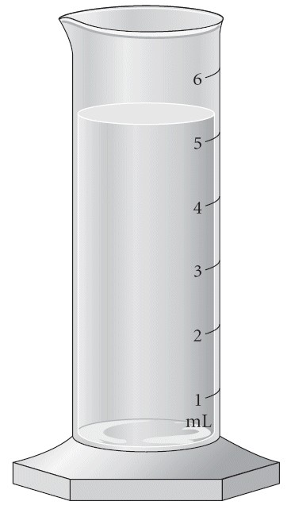
A) 5 mL
B) 5.3 mL
C) 5.32 mL
D) 5.320 mL
E) 5.3200 mL

11) Read the temperature with the correct number of significant figures.
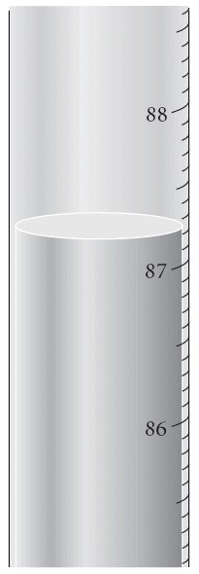
A) 87°C
B) 87.2°C
C) 87.20°C
D) 87.200°C
E) 87.2000°C
12) Which of the following is an example of the law of multiple proportions?
A) A sample of chlorine is found to contain three times as much Cl-35 as Cl-37.
B) Two different compounds formed from carbon and oxygen have the following mass ratios:
1.33 g O: 1 g C and 2.66 g O: 1 g C.
C) Two different samples of table salt are found to have the same ratio of sodium to chlorine.
D) The atomic mass of bromine is found to be 79.90 amu.
E) Nitrogen dioxide always has a mass ratio of 2.28 g O: 1 g N.

13) Identify the charges of the protons, neutrons, and electrons.
A) protons +1, neutrons 0, electrons -1
B) protons 0, neutrons -1, electrons +1
C) protons -1, neutrons 0, electrons +1
D) protons 0, neutrons +1, electrons -1
E) protons +1, neutrons -1, electrons 0

14) The mass number is equal to
A) the sum of the number of the electrons and protons.
B) the sum of the number of the neutrons and electrons.
C) the sum of the number of protons, neutrons, and electrons.
D) the sum of the number of protons and neutrons.

15) Determine the number of protons, neutrons and electrons in the following:
A) p+ = 18 n° = 18 e- = 22
B) p+ = 18 n° = 22 e- = 18
C) p+ = 22 n° = 18 e- = 18
D) p+ = 18 n° = 22 e- = 40
E) p+ = 40 n° = 22 e- = 18

16) What element is defined by the following information?

p+ = 11 n° = 12 e- = 11

A) sodium
B) vanadium
C) magnesium
D) titanium

17) Identify a cation.
A) An atom that has lost an electron.
B) An atom that has gained an electron.
C) An atom that has lost a proton.
D) An atom that has gained a proton.

18) Which of the following elements is a halogen?
A) Ne
B) I
C) O
D) Mg
E) K

19) Calculate the atomic mass of silver if silver has 2 naturally occurring isotopes with the following masses and natural abundances:

Ag-107 106.90509 amu 51.84%
Ag-109 108.90476 amu 48.46%

A) 107.90 amu
B) 108.00 amu
C) 107.79 amu
D) 108.32 amu
E) 108.19 amu

20) How many atoms are in 2.50 moles of CO2?
A) 4.52 x 1024 atoms
B) 1.52 x 1024 atoms
C) 5.02 x 1023 atoms
D) 3.01 x 1024 atoms
E) 7.53 x 1023 atoms

21) Calculate the mass (in g) of 1.9 x 1024 atoms of Pb.
A) 3.9 × 102 g
B) 2.4 × 102 g
C) 3.2 × 102 g
D) 1.5 × 102 g
E) 6.5 × 102 g

22) An ionic bond is best described as
A) the sharing of electrons.
B) the transfer of electrons from one atom to another.
C) the attraction that holds the atoms together in a polyatomic ion.
D) the attraction between 2 nonmetal atoms.
E) the attraction between 2 metal atoms.

23) A covalent bond is best described as
A) the sharing of electrons between atoms.
B) the transfer of electrons.
C) a bond between a metal and a nonmetal.
D) a bond between a metal and a polyatomic ion.
E) a bond between two polyatomic ions.
24) Which of the following contains BOTH ionic and covalent bonds?
A) CaI2
B) COS
C) CaSO4
D) SF6
E) None of the above contain both ionic and covalent bonds.

25) What is the empirical formula for C4H10O2?
A) C2H5O
B) CHO
C) C2H4O
D) CHO2
E) CH2O

26) Which of the following exists as a diatomic molecule?
A) N
B) C
C) P
D) Na
E) Ne

27) Write the formula for the compound formed between potassium and sulfur.
A) KS
B) KS2
C) K2S
D) K2SO3
E) K3S2

28) Write the formula for barium nitrite.
A) Ba3N2
B) BaNO3
C) BN
D) Ba(NO2)2
E) B(NO2)3

29) Determine the name for TiCO3. Remember that titanium forms several ions.
A) titanium(II) carbonate
B) titanium carbide
C) titanium carbonite
D) titanium(II) carbonite
E) titanium(I) carbonate

30) Write the name for Sn(SO4)2. Remember that Sn forms several ions.
A) tin(I) sulfite
B) tin(IV) sulfate
C) tin sulfide
D) tin(II) sulfite
E) tin(I) sulfate

31) Give the correct formula for sodium chlorate.
A) NaClO
B) NaClO2
C) NaClO3
D) NaClO4

32) Determine the name for HClO3.
A) hydrochloric acid
B) hydrochlorus acid
C) chlorate acid
D) chloric acid
E) perchloric acid

33) What is the mass (in kg) of 6.89 × 1025 molecules of CO2
A) 3.85 kg
B) 5.04 kg
C) 2.60 kg
D) 3.03 kg
E) 6.39 kg

34) Give the mass percent of carbon in C14H19NO2.
A) 38.89%
B) 72 .07%
C) 5.17%
D) 2.78%

35) Give the mass percent of hydrogen in C14H19NO2.
A) 38.89%
B) 72 .07%
C) 8.15%
D) 2.78%

36) Write a balanced equation to show the reaction of aqueous aluminum acetate with aqueous ammonium phosphate to form solid aluminum phosphate and aqueous ammonium acetate.
A) Al(C2H3O2)2 (aq) + (NH4)2PO4 (aq) → AlPO4 (s) + 2 NH4C2H3O2 (aq)
B) Al(C2H3O2)2 (aq) + (NH3)2PO4 (aq) → AlPO4 (s) + 2 NH3C2H3O2 (aq)
C) Al(CO3)2 (aq) + (NH3)2PO4 (aq) → AlPO4 (s) + 2 NH3CO3 (aq)
D) Al(C2H3O2)3 (aq) + (NH4)3PO4 (aq) → AlPO4 (s) + 3 NH4C2H3O2 (aq)
E) Al(CO2)3 (aq) + (NH4)3PO3 (aq) → AlPO3 (s) + 3 NH4CO2 (aq)

37) According to the following balanced reaction, how many moles of NO are formed from 8.44 moles of NO2 if there is plenty of water present?

3 NO2(g) + H2O(l) → 2 HNO3(aq) + NO(g)

A) 2.81 moles NO
B) 25.3 moles NO
C) 8.44 moles NO
D) 5.63 moles NO
E) 1.83 moles NO

38) According to the following balanced reaction, how many moles of HNO3 are formed from 8.44 moles of NO2 if there is plenty of water present?

3 NO2(g) + H2O(l) → 2 HNO3(aq) + NO(g)

A) 2.81 moles HNO3
B) 25.3 moles HNO3
C) 8.44 moles HNO3
D) 5.63 moles HNO3
E) 1.83 moles HNO3

39) According to the following balanced reaction, how many moles of HNO3 are formed from 8.44 moles of NO2 if there is plenty of water present?

3 NO2(g) + H2O(l) → 2 HNO3(aq) + NO(g)

A) 2.81 moles HNO3
B) 25.3 moles HNO3
C) 8.44 moles HNO3
D) 5.63 moles HNO3
E) 1.83 moles HNO3

40) According to the following reaction, how many grams of sulfur are formed when 37.4 g of water are formed?
2 H2S(g) + SO2(g) → 3 S(s) + 2H2O(l)

A) 99.8 g S
B) 66.6 g S
C) 56.1 g S
D) 44.4 g S
E) 14.0 g S

41) How many molecules of H2S are required to form 79.0 g of sulfur according to the following reaction? Assume excess SO2.

2 H2S(g) + SO2(g) → 3 S(s) + 2H2O(l)

A) 1.48 × 1024 molecules H2S
B) 9.89 × 1023 molecules H2S
C) 5.06 × 1025 molecules H2S
D) 3.17 × 1025 molecules H2S
E) 2.44 × 1023 molecules H2S

42) Determine the limiting reactant (LR) and the mass (in g) of nitrogen that can be formed from 50.0 g N2O4 and 45.0 g N2H4. Some possibly useful molar masses are as follows: N2O4 = 92.02 g/mol, N2H4 = 32.05 g/mol.

N2O4(l) + 2 N2H4(l) → 3 N2(g) + 4 H2O(g)

A) LR = N2H4, 59.0 g N2 formed
B) LR = N2O4, 105 g N2 formed
C) LR = N2O4, 45.7 g N2 formed
D) LR = N2H4, 13.3 g N2 formed
E) No LR, 45.0 g N2 formed

43) Determine the percent yield of a reaction that produces 28.65 g of Fe when 50.00 g of Fe2O3 react with excess Al according to the following reaction.

Fe2O3(s) + 2 Al(s) → Al2O3(s) + 2 Fe(s)
A) 61.03 %
B) 28.65 %
C) 57.30 %
D) 20.02 %
E) 81.93 %

44) What volume (in mL) of 0.0887 M MgF2 solution is needed to make 275.0 mL of 0.0224 M MgF2 solution?
A) 72.3 mL
B) 91.8 mL
C) 10.9 mL
D) 69.4 mL
E) 14.4 mL

45) Determine the molarity of a solution formed by dissolving 468 mg of MgI2 in enough water to yield 50.0 mL of solution.
A) 0.0297 M
B) 0.0337 M
C) 0.0936 M
D) 0.0107 M
E) 0.0651 M

46) Which of the following is NOT a strong electrolyte?
A) LiOH
B) CaCl2
C) MgCO3
D) NaC2H3O2
E) Li2SO4

47) Identify HCl.
A) strong electrolyte, weak acid
B) weak electrolyte, weak acid
C) strong electrolyte, strong acid
D) weak electrolyte, strong acid
E) nonelectrolyte

48) Identify sugar.
A) strong electrolyte, weak acid
B) weak electrolyte, weak acid
C) strong electrolyte, strong acid
D) weak electrolyte, strong acid
E) nonelectrolyte

49) Convert 1.25 atm to mm Hg.
A) 760 mm Hg
B) 875 mm Hg
C) 950 mm Hg
D) 1000 mm Hg
E) 1520 mm Hg

50) The volume of a gas is proportional to the temperature of a gas is known as
A) Avogadro's Law
B) Ideal Gas Law
C) Charles's Law
D) Boyle's Law
E) Dalton's Law

51) The volume of a gas is proportional to number of moles of a gas is known as
A) Avogadro's Law
B) Ideal Gas Law
C) Charles's Law
D) Boyle's Law
E) Dalton's Law

52) The volume of a gas is inversely proportional to the pressure of a gas is known as
A) Avogadro's Law
B) Ideal Gas Law
C) Charles's Law
D) Boyle's Law
E) Dalton's Law

53) A gas occupies 3.33 L at 2.23 atm. What is the volume at 2.50 atm?
A) 1.67 L
B) 3.73 L
C) 2.97 L
D) 0.268 L
E) 18.6 L

54) If a sample of 0.29 moles of Ar occupies 3.8 L under certain conditions, what volume will 0.66 moles occupy under the same conditions?
A) 12 L
B) 8.6 L
C) 17 L
D) 5.0 L
E) 15 L

55) To what temperature must a balloon, initially at 25°C and 2.00 L, be heated in order to have a volume of 6.00 L?
A) 993 K
B) 403 K
C) 75 K
D) 655 K
E) 894 K

56) A gas is at 35.0°C and 4.50 L. What is the temperature at 9.00 L?
A) 343°C
B) 70.0°C
C) 616°C
D) 1.16°C
E) 17.5°C

57) A sample of gas initially has a volume of 859 mL at 565 K and 2.20 atm. What pressure will the sample have if the volume changes to 268 mL while the temperature is increased to 815 K?
A) 10.2 atm
B) 9.83 atm
C) 15.3 atm
D) 6.53 atm
E) 1.05 atm

58) Calculate the temperature, in K, of 2.20 moles of gas occupying 3.50 L at 3.30 atm.
A) 64.0 K
B) 5.25 K
C) 337 K
D) 28.0 K

59) Give the temperature and pressure at STP.
A) 0 °C and 1.00 atm
B) 0K and 1.00 atm
C) 25 °C and 30.00 in Hg
D) 300K and 1 torr Hg
E) 0 °C and 1 mm Hg

60) Which of the following samples will have the greatest volume at STP?
A) 22 g CO
B) 22 g He
C) 22 g O2
D) 22 g Cl2
E) All of these samples would have the same volume at STP.

61) Which of the following samples has the greatest density at STP?
A) NO2
B) Xe
C) SO2
D) SF6
E) All of these samples have the same density at STP.

62) A mixture of 1.0 mol He and 1.0 mol Ne are at STP in a rigid container. Which of the following statements is TRUE?
A) Both gases have the same average kinetic energy.
B) Both gases contribute equally to the density of the mixture under these conditions.
C) Both gases have the same molecular speed.
D) The mixture has a volume of 22.4 L
E) All of the above are TRUE.

63) Define heat capacity.
A) the quantity of heat required to raise the temperature of 1 mole of a substance by 1°C
B) the quantity of heat required to change a system's temperature by 1°C
C) the quantity of heat required to raise the temperature of 1 gram of a substance by 1°C
D) the quantity of heat required to raise the temperature of 1 g of a substance by 1°F
E) the quantity of heat required to raise the temperature of 1 liter of a substance by 1°C

64) Calculate the amount of heat (in kJ) required to raise the temperature of a 79.0 g sample of ethanol from 298.0 K to 385.0 K. The specific heat capacity of ethanol is 2.42 J/g°C.
A) 57.0 kJ
B) 16.6 kJ
C) 73.6 kJ
D) 28.4 kJ
E) 12.9 kJ

65) A sample of copper absorbs 43.6 kJ of heat, resulting in a temperature rise of 75.0 °C, determine the mass (in kg) of the copper sample if the specific heat capacity of copper is 0.385 J/g°C.
A) 1.51 kg
B) 6.62 kg
C) 1.26 kg
D) 7.94 kg
E) 3.64 kg

66) Which of the following processes is endothermic?
A) the freezing of water
B) the combustion of propane
C) a hot cup of coffee (system) cools on a countertop
D) the chemical reaction in a "hot pack" often used to treat sore muscles
E) the vaporization of rubbing alcohol

67) Which of the following processes is exothermic?
A) the formation of dew in the morning
B) the melting of ice
C) the chemical reaction in a "cold pack" often used to treat injuries
D) the vaporization of water
E) None of the above are exothermic.

68) Describe the shape of a s orbital.
A) a ball
B) two balls
C) three balls
D) four balls
E) eight balls

69) Describe the shape of a p orbital.
A) a ball
B) two balls
C) three balls
D) four balls
E) eight balls

70) Give the number of core electrons for O.
A) 0
B) 1
C) 2
D) 3
E) 4

71) Give the number of valence electrons for O.
A) 0
B) 1
C) 2
D) 3
E) 6

72) Give the electron configuration for O.
A) 1s22s22p4
B) 1s22p4
C) 1s22s22p3
D) 1s22s22p5
E) 1s22s22p2

73) The element that corresponds to the electron configuration 1s22s22p6 is __________.
A) sodium
B) magnesium
C) lithium
D) beryllium
E) neon

74) The condensed electron configuration of silicon, element 14, is __________.
A) [He]2s42p6
B) [Ne]2p10
C) [Ne]3s23p2
D) [He]2s4
E) [He]2s62p2

75) The condensed electron configuration of krypton, element 36, is __________.
A) [Kr]4s23d8
B) [Ar]4s4
C) [Kr]4s43d8
D) [Ar]3d104s24p6
E) [Ar]4s43d4

76) Give the ground state electron configuration for Pb.
A) [Xe]6s26p2
B) [Xe]6s25d106p2
C) [Xe]6s25f146d106p2
D) [Xe]6s24f145d106p2
E) [Xe]6s24f145d106s26p2

77) Give the number of valence electrons for Cd.
A) 8
B) 10
C) 12
D) 2
E) 6

78) How many valence electrons does an atom of S have?
A) 3
B) 1
C) 2
D) 4
E) 6

79) How many valence electrons does an atom of Al possess?
A) 1
B) 2
C) 5
D) 3
E) 8

80) Identify the compound with ionic bonding.
A) NaCl
B) Li
C) H2O
D) He
E) S

81) Which of the following statements is TRUE?
A) A covalent bond is formed through the transfer of electrons from one atom to another.
B) A pair of electrons involved in a covalent bond are sometimes referred to as "lone pairs."
C) It is not possible for two atoms to share more than two electrons.
D) Single bonds are shorter than double bonds.
E) A covalent bond has a lower potential energy than the two separate atoms.

82) Which of the following represent the Lewis structure for N?
A) 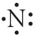
B) 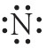
C) 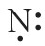
D) 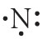
E) 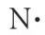

83) Which of the following represent the Lewis structure for Mg?
A) 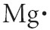
B) 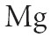
C) 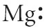
D) 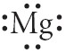
E) 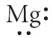

84) Which of the following represent the Lewis structure for S2⁻?
A) 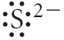
B) 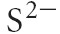
C) 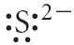
D) 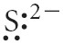
E) 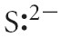

85) Use Lewis theory to determine the chemical formula for the compound formed between Mg and Br.
A) MgBr
B) Mg2Br3
C) Mg3Br2
D) MgBr2
E) Mg2Br

86) Use Lewis theory to determine the chemical formula for the compound formed between Rb and Br.
A) RbBr
B) Rb2Br3
C) Rb3Br2
D) RbBr2
E) Rb2Br

87) A triple covalent bond contains __________ of electrons.
A) 0 pairs
B) 1 pair
C) 2 pairs
D) 3 pairs
E) 4 pairs

88) Choose the bond below that is most polar.
A) H-I
B) H-Br
C) H-F
D) H-Cl
E) C-H

89) Choose the best Lewis structure for OCl2.
A) 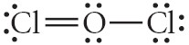
B) 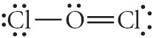
C) 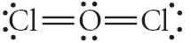
D) 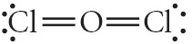
E) 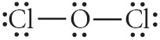

90) Choose the best Lewis structure for NO3⁻.

A)
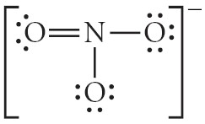
B)
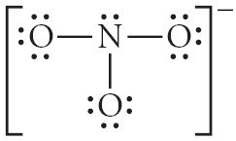
C)
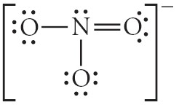
D)
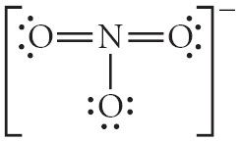
E)
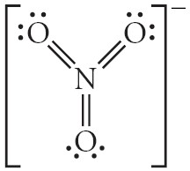

91) Give the number of valence electrons for SO42-.
A) 32
B) 30
C) 34
D) 28
E) 36

92) Choose the best Lewis structure for NH4⁺.

A)
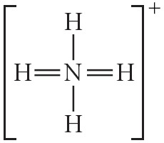
B)
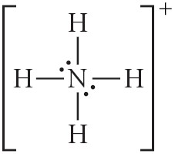
C)
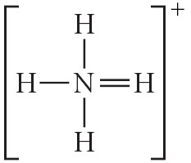
D)
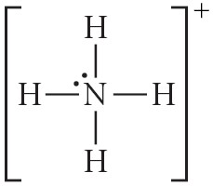
E)
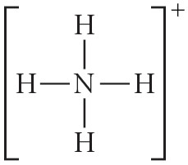

93) Give the approximate bond angle for a molecule with a trigonal planar shape.
A) 109.5°
B) 180°
C) 120°
D) 105°
E) 90°

94) Give the approximate bond angle for a molecule with a tetrahedral shape.
A) 109.5°
B) 180°
C) 120°
D) 105°
E) 90°

95) Give the approximate bond angle for a molecule with a linear shape.
A) 109.5°
B) 180°
C) 120°
D) 105°
E) 90°

96) Determine the electron geometry (eg) and molecular geometry (mg) of CO32⁻.
A) eg=tetrahedral, mg=tetrahedral
B) eg=tetrahedral, mg=trigonal pyramidal
C) eg=trigonal planar, mg=bent
D) eg=trigonal planar, mg=trigonal planar
E) eg=tetrahedral, mg=trigonal planar

97) Determine the electron geometry (eg) and molecular geometry (mg) of CO2.
A) eg=tetrahedral, mg=tetrahedral
B) eg=linear, mg=trigonal planar
C) eg=trigonal planar, mg=bent
D) eg=linear, mg=linear
E) eg=trigonal planar, mg=trigonal planar

98) Determine the electron geometry (eg) and molecular geometry (mg) of NCl3.
A) eg=tetrahedral, mg=tetrahedral
B) eg=linear, mg=trigonal planar
C) eg=trigonal planar, mg=bent
D) eg=linear, mg=linear
E) eg=tetrahedral, mg=trigonal pyramidal

99) The forces between polar molecules is known as __________.
A) hydrogen bonding
B) ion-dipole forces
C) dipole-dipole forces
D) dispersion forces
E) ionic forces

100) What is the strongest type of intermolecular force present in H2?
A) ion-dipole
B) dipole-dipole
C) dispersion
D) hydrogen bonding
E) none of the above

101) What is the strongest type of intermolecular force present in CHF3?
A) ion-dipole
B) dispersion
C) hydrogen bonding
D) dipole-dipole
E) none of the above

102) Place the following compounds in order of increasing strength of intermolecular forces.

CO2 F2 NH2CH3

A) NH2CH3 < CO2 < F2
B) F2 < NH2CH3 < CO2
C) NH2CH3 < F2 < CO2
D) F2 < CO2 < NH2CH3
E) CO2 < NH2CH3 < F2

103) Place the following compounds in order of increasing strength of intermolecular forces.

CH4 CH3CH2CH3 CH3CH3

A) CH3CH2CH3 < CH4 < CH3CH3
B) CH3CH2CH3 < CH3CH3 < CH4
C) CH3CH3 < CH4 < CH3CH2CH3
D) CH4 < CH3CH2CH3 < CH3CH3
E) CH4 < CH3CH3 < CH3CH2CH3

104) Identify the compound that does not have hydrogen bonding.
A) (CH3)3N
B) H2O
C) CH3OH
D) HF
E) CH3NH2

105) Which of the following compounds exhibits only dispersion and dipole-dipole intermolecular interactions?
A) H2
B) HI
C) CO2
D) CH3NH2

106) Which of the following statements is TRUE?
A) Vapor pressure increases with temperature.
B) Hydrogen bonds are stronger than covalent bonds.
C) Intermolecular forces hold the atoms in molecules together.
D) Dispersion forces are generally stronger than dipole-dipole forces.
E) None of the above are true.

107) Define boiling.
A) A liquid becomes a gas.
B) A gas becomes a liquid.
C) A gas becomes a solid.
D) A solid becomes a gas.
E) A solid becomes a liquid.

108) Place the following substances in order of increasing boiling point.

CH3CH2OH Ar CH3OCH3

A) Ar < CH3OCH3 < CH3CH2OH
B) CH3CH2OH < Ar < CH3OCH3
C) CH3CH2OH < CH3OCH3 < Ar
D) CH3OCH3 < Ar < CH3CH2OH
E) Ar < CH3CH2OH < CH3OCH3

109) Define freezing.
A) the phase transition from solid to gas
B) the phase transition from gas to solid
C) the phase transition from gas to liquid
D) the phase transition from liquid to gas
E) the phase transition from liquid to solid

110) Which Brønsted-Lowry acid is not considered to be a strong acid in water?
A) HBr
B) HCl
C) HNO₂
D) HClO₄
E) H₂SO₄

111) Calculate the hydroxide ion concentration in an aqueous solution that contains 3.50 × 10⁻³ M in hydronium ion.
A) 2.86 × 10⁻⁴ M
B) 2.86 × 10⁻¹¹ M
C) 2.86 × 10⁻¹² M
D) 3.50 × 10⁻¹² M
E) 3.50 × 10⁻⁴ M

112) A solution with a hydroxide ion concentration of 4.15 × 10⁻⁴ M is _____________.
A) acidic
B) basic
C) neutral
D) 2.41 × 10⁻¹¹ M
E) not enough information

113) What is the pH of a 0.040 M HClO₄ solution?
A) 0.040
B) 0.080
C) 1.40
D) 12.60
E) 7

114) What is the pH of a 0.040 M Ca(OH)₂ solution?
A) 1.10
B) 1.40
C) 12.60
D) 12.90
E) 7.00

115) How many milliliters of 0.550 M hydroiodic acid are needed to react with 20.00 mL of 0.217 M cesium hydroxide?
HI _{(aq)} + CsOH _{(aq)} → CsI _{(aq)} + H₂O _{(l)}
A) 0.0197 mL
B) 0.127 mL
C) 7.89 mL
D) 50.7 mL
E) 20.00 mL

