Practice on Quantum Numbers key
- Answer the following:
- How many orbitals in the l = 1 subshell?
The l = 1 subshell is also called the p subshell. All p subshells contain 3 orbitals.
- What is the maximum number of electrons in a d subshell?
All d subshells contain 10 electrons.
- What is the subshell designation when n = 3 and l = 2?
The l = 2 subshell is also called the d subshell. So the subshell designation is 3d.
- How many subshells in the n = 4 shell?
The n = 4 shell contains 4 subshells.
- Briefly explain what the term degeneracy means when used to describe features of the energy level diagram for a multi-electron atom.
Degeneracy means equal in energy. In a multi-electron atom, orbitals in the same subshell are degenerate. For example the three orbitals in the p subshell are all degenerate in energy.
- Briefly describe the difference between an orbit and an orbital as it relates to an electron in a hydrogen atom.
An orbit is a circular path around the nucleus. According to Bohr's model, only orbits with specific radii are allowed. Orbits are specified by a single quantum number. An orbital is a volume of space specified by 3 quantum numbers where the probability of finding the electron is greatest.
- Sketch the orbital diagram for the valence electrons in copper.
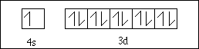

- Write the short hand electron configuration for each of the following.
a) Cu [Ar] 4s ¹3d¹⁰
b) Ca²⁺ [Ne]3s ²3p⁶
c) Po [Xe] 6s ²4f¹⁴5d¹⁰6p⁴
d) Se²⁻[Ar] 4s²3d¹⁰4p⁶
e) Ir [Xe] 6s²4f¹⁴5d⁷
- Write the possible set of quantum numbers for all valence electron in an antimony (Sb) atom in its ground state.
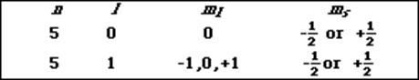
- Given the five orbital diagrams labeled A, B, C, D, and E.
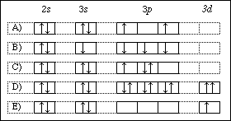
From the orbital diagrams select an example which demonstrates
i). a violation of Hund's rule C
ii). a violation of the Pauli exclusion principle D
iii). a ground state orbital diagram A
iv). an excited state orbital diagram E or B
v). a violation of the Aufbau principle B or E

