Exam 3

# Part 1: Multiple Choice (2 points each)

## Directions: Please circle the *best* answer for each of the following questions.

1. Bonding orbitals are __________ and antibonding orbitals are __________ in energy than atomic orbitals.
   1. lower, lower
   2. lower, higher
   3. higher, lower
   4. higher, higher
   5. same, same
2. What is the atomic number of the as yet undiscovered element in which the 8s and 8p electron energy levels fill?
3. 118
4. 6
5. 168
6. 8
7. 888
8. Which atom would be expected to have the largest third ionization energy? Consider the following electron configurations for neutral atoms:
   * 1. I: 1s22s22p63s2
     2. II: 1s22s22p63s23p4
     3. III: 1s22s22p63s23p6
9. atom I
10. atom II
11. atom III
12. atom I and II
13. all of the above
14. How many electrons does a dsp3 orbital hold?
15. 10
16. 8
17. 6
18. 4
19. 2
20. Which of the following ionic compounds would be expected to have the highest lattice energy?
21. Cesium fluoride
22. Cesium chloride
23. Cesium bromide
24. Cesium iodide
25. All have the same lattice energy
26. Which ion does not have a noble gas configuration in its ground state?
27. Sc3+
28. Al3+
29. Ga3+
30. As3-
31. none of the above
32. The phosphorus atom in phosphorous trichloride would be expected to have
33. a partial positive (δ+) charge
34. a partial negative (δ-) charge
35. a 3+ charge
36. a 3- charge
37. a 0 charge
38. What are the F-S-F bond angles in sulfur hexafluoride?
39. 90° and 120°
40. 90°
41. 109.5°
42. 120°
43. 180°
44. Which experiment did not use a balance?
45. Propagation of Error
46. Alloy Analysis
47. Titration
48. Calorimetry
49. none of the above
50. In general, in what order should the following steps be taken when responding to a chemical spill?
    1. Communicate, isolate, mitigate, evacuate.
    2. Isolate, evacuate, mitigate, communicate.
    3. Evacuate, communicate, isolate, mitigate.
    4. Evaluate, isolate, mitigate, communicate.
    5. all of the above

# Part 2: Short Answer

## Directions: Answer each of the following questions. Be sure to use complete sentences where appropriate. For full credit be sure to show all of your work.

1. Given the following data (12 points):

Mg (s) → Mg (g) ∆H° = 148 kJ

F2 (g) → 2 F (g) ∆H° = 159 kJ

Mg (g) → Mg+ (g) + e- ∆H° = 738 kJ

Mg+ (g) → Mg2+ (g) + e- ∆H° = 1450 kJ

F (g) + e- → F- (g) ∆H° = -328 kJ

Mg (s) + F2 (g) → MgF2 (s) ∆H° = -1123 kJ

* 1. Use the following to calculate the ∆H°lattice of MgF2:

∆H°lattice = -1123 kJ – 148 kJ – 159 kJ – 738 kJ – 1450 kJ – 2(-328 kJ) = -2962 kJ

* 1. Compared with the lattice energy of LiF (1050 kJ/mol) or the lattice energy of NaCl (788 kJ), does the relative magnitude of the value for MgF2 surprise you? Explain.

No, both of these compounds have +1 and -1 charges, whereas MgF2 has a +2 and -1 charge, because E α q1q2 and the magnitude of the charges is higher the lattice energy should also be higher.

1. Use the concepts of effective nuclear charge, shielding, and *n* value of the valence orbital to explain the trend in atomic radius as you move across a period in the periodic table from left to right (5 points).

As you move across a row in the periodic table, the n level stays the same. However, the nuclear charge increases and the amount of shielding stays about the same since the number of inner electrons stays about the same. So, the effective nuclear charge experienced by the electrons in the outermost principal energy level increases, resulting in a stronger attraction between the outermost electrons and the nucleus and therefore, a smaller atomic radii.

1. How are electron affinity and electronegativity different (5 points)?

Electron affinity is the process of a single atom gaining an electron. Electronegativity is the strength of the attraction of a nucleus to a pair of shared (bonded) electrons within a covalent bond. Electronegativity is only important when looking at covalent bonds and electron affinity is only important when considering single atoms gaining electrons to form anions.

1. Draw Lewis electron dot structure for POCl3 (P is central). Draw a structure that obeys the octet rule and then show any other structures which may better represent the molecule. Include formal charges and explain which structure is preferred and why (6 points).

 

Obeys octet rule minimizes charges – better structure

1. Two structures may be drawn for C4H5N2OBr (8 points):

 

Structure a Structure b

* 1. Are these two resonance structures of the same molecule? Explain.

These are different molecules because they have different skeleton structures; therefore they are isomers. Resonance structures must have the same skeleton structure!

* 1. How many sigma bonds are in structure a? __12______
  2. How many pi bonds?____3____
  3. Which bonds are longer, the CC bonds in structure a or b? Explain.

The CC bonds in b are longer because single bonds are longer than triple bonds.

* 1. Which bonds are stronger, the CN bonds in a or b? Explain.

The CN bonds in b are stronger because double bonds are stronger than single bonds.

|  |  |
| --- | --- |
| Bond | Energy (kJ/mol) |
| C-C | 346 |
| C=C | 610 |
| C≡C | 812 |
| Br-Br | 193 |
| C-H | 346 |
| C-Br | 285 |
| H-Br | 366 |

1. Acetylene reacts with bromine according to the following equation (10 points):

C2H2 (g) + 2 Br2 (l) ⎯→ C2H2Br4 (g)

From bond energies, calculate the standard enthalpy change for the reaction.



$$∆H_{rxn}=\sum{bonds broken}-\sum{bonds formed}$$

$$∆H_{rxn}=[\left(1 mol\right){(∆H}_{C≡C})+\left(2 mol\right){(∆H}_{C-H})+(2 mol)(∆H_{Br-Br})]-[\left(4 mol\right){(∆H}_{C-Br})+\left(2 mol\right){(∆H}_{C-H})+(1 mol)(∆H_{C-C})]$$

$$∆H_{rxn}=\left[\left(1 mol\right)\left(812\frac{kJ}{mol}\right)+\left(2 mol\right)\left(193\frac{kJ}{mol}\right)\right]-\left[\left(4 mol\right)\left(285\frac{kJ}{mol}\right)+\left(1 mol\right)\left(346\frac{kJ}{mol}\right)\right]$$

$$∆H_{rxn}=812 kJ+386 kJ-1140 kJ-346 kJ=-288 kJ$$

1. Match the orbitals below to the correct description (4 points).

Sigma type bonding orbital C

Sigma type antibonding orbital A

Pi type bonding orbital B

Pi type antibonding orbital D

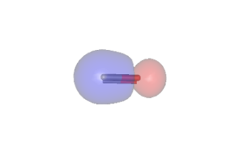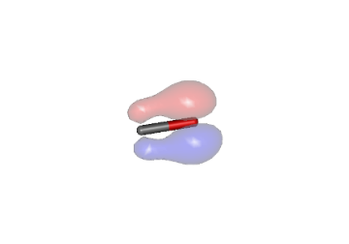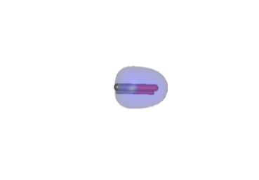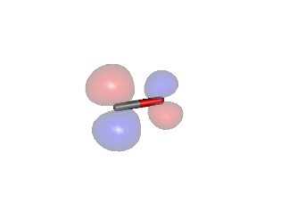 A B C D

1. Give the orbital geometry, molecular geometry, hybridization, and formal charge for each of the highlighted atoms below (12 points):



|  |  |  |  |  |
| --- | --- | --- | --- | --- |
| atom | orbital geometry | molecular geometry | hybridization | formal charge |
| Bromine (a) | Octahedral | Square planar | sp3d2 | -1 |
| Phosphorus (b) | Tetrahedral | Trigonal pyramidal | sp3 | 0 |
| Xenon (c) | Trigonal bipyramidal | See saw | sp3d | +2 |
| Carbon(d) | linear | linear | sp | 0 |

1. Look at the compound pictured below. Explain the bonding in terms of valence bond theory. That is show the atomic orbitals on the I atom, describe any electron promotion and hybridization necessary, and label the orbitals involved in both sigma and pi bonding as well as the orbital holding the lone pair of electrons on I. You do not need to draw a 3D representation of the orbitals (8 points).



I $\underset{5s}{\underbrace{\boxed{↑↓}}} \underset{5p}{\underbrace{\boxed{↑↓} \boxed{↑↓} \boxed{↑ }}} \underset{5d}{\underbrace{\boxed{} \boxed{} \boxed{} \boxed{} \boxed{}}}$

Promotion

I $\underset{5s}{\underbrace{\boxed{↑↓}}} \underset{5p}{\underbrace{\boxed{↑ } \boxed{↑ } \boxed{↑ }}} \underset{5d}{\underbrace{\boxed{↑ } \boxed{↑ } \boxed{} \boxed{} \boxed{}}}$

Hybridization

I $\underset{sp^{3}}{\underbrace{\overset{\begin{aligned}lone \\ pair\end{aligned}}{\overbrace{\boxed{↑↓ }}} \overset{σ bonds}{\overbrace{\boxed{↑ } \boxed{↑ }\boxed{↑ } }}}} \underset{ d}{\underbrace{ \overset{π bonds}{\overbrace{\boxed{↑ }\boxed{↑ }}}}}$

1. Draw molecular orbital diagrams for C2−, C2, and C2+ and answer the questions below regarding these species (10 points).
   1. Give the bond order in all species

C2− 2.5 C2+ 1.5 C2  2

* 1. Rank these species in order of increasing bond length___ C2-__<__ C2____<___ C2+___
  2. Rank these species in order of increasing bond strength___ C2+___<__ C2____<___ C2-_
  3. Identify each species as diamagnetic or paramagnetic

C2−paramagnetic C2+paramagnetic C2 diamagnetic

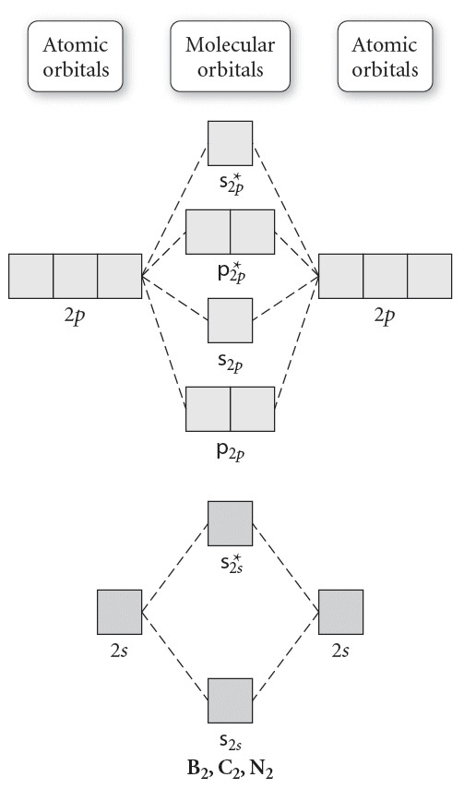 

C2

C2−

 

C2+