Exam 3

Part 1: Multiple Choice (2 points each)

Directions: Please circle the best answer for each of the following questions.

- A shell consists of all ________
  - electrons with the same quantum number.
  - orbitals with the same quantum numbers.
  - orbitals with the same principal quantum number.
  - electrons with the same magnetic quantum number.
  - orbitals with the same and m_{l} quantum numbers.

- Which of the following is not an allowed value for the principal quantum number?
  - 0
  - 1
  - 2
  - 3
  - 10

- Atomic spectra are due to the changes in the energy of ________
  - protons.
  - neutrons.
  - nuclei.
  - electrons.
  - electromagnetic radiation.

- Which of the following electron configurations represents an excited state?
  - [Ne]3s²3p⁵
  - [Kr]4d¹⁰5s²5p¹
  - [Ar]3d¹⁰4s²4p⁶
  - [Ne]3s²3p⁶4s¹
  - [Kr]4d¹⁰5s¹5p¹

- Which of the following oxoacids would you predict not to exist?
  - HFO₄
  - HClO₄
  - HBrO₄
  - HIO₄
  - HClO
- What are the hybridizations of the carbon atoms in CH₃CH₂(CO)H, in order from left to right? Note that the C=O bond is a double bond.
  - sp³, sp³, sp²
  - sp³, sp³, sp³
  - sp³, sp², sp³
  - sp², sp², sp³
  - sp³, sp², sp²
- Which of the following substances is a solid at 25°C and 1 atm?

  - 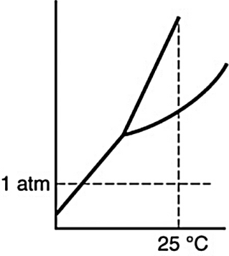
  - 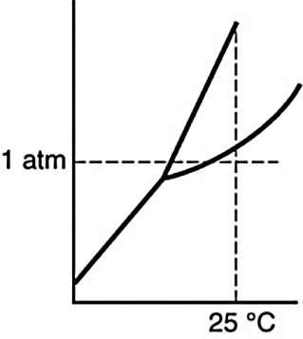
  - 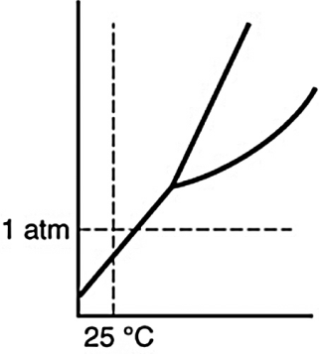
  - 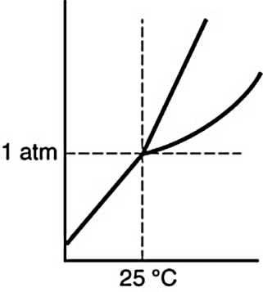

- Which is the dominant interaction between oxygen and nitrogen molecules in air?
  - ion–ion
  - ion–dipole
  - dipole–dipole
  - hydrogen bonding
  - dispersion or London forces

- The vapor pressure of a liquid increases with increasing temperature because ________
  - more molecules can escape from the liquid because their average kinetic energy is greater.
  - the number of gas molecules above the liquid does not change but their average kinetic energy increases.
  - the molecules in the liquid move faster and exert a greater pressure.
  - the ideal gas law states that the pressure is proportional to the temperature.
  - molecules interact less strongly at higher temperatures.

- What are the F-Po-F bond angles in polonium(VI) fluoride?
- 90°
- 109.5°
- 120°
- 180°
- 90° and 120°

Part 2: Short Answer

Directions: Answer each of the following questions. Be sure to use complete sentences where appropriate. For full credit be sure to show all of your work.
- A light detector based on the photoelectric effect is made with cesium metal. Cesium metal has a work function of 3.40 × 10^{–19} J (6 points).
  - What is the longest wavelength in nm of light that one could expect to detect with this device?

  - What is the frequency of the light?

- Astronomers have detected hydrogen atoms in interstellar space in the n = 732 energy level. Suppose an atom in this excited state emits a photon and undergoes a transition from n = 732 to n = 721 (8 points).
  - How much energy does the atom lose as a result of this transition?

  - What is the wavelength of the emitted photon, R_{H} = 1.097 × 10⁷ m⁻¹?

  - In which spectral region does this radiation lie? ______________________________

- Consider the radial distribution shown below for an electron in an s atomic orbital where r is the distance of the electron from the nucleus (4 points).
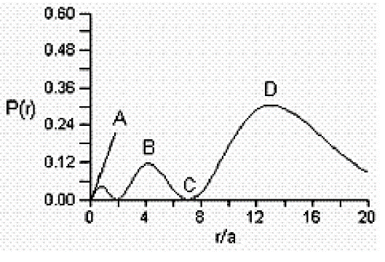
Identify: (1) where the atomic nucleus is located; (2) a radial node; (3) the most probable distance of the electron from the nucleus; and (4) the principle quantum number for this orbital.

- Cyanogen is a gas which contains 46.2% C and 53.8% N by mass. At a temperature of 25 °C and a pressure of 750 mm Hg, 1.50 g of cyanogen occupies 0.714 L (18 points).
  - What is the molecular formula of cyanogen?

  - Draw the best Lewis structure for cyanogen, and label the orbital geometry, molecular geometry, bond angle, and hybridization of the central atom(s).

Bond | Bond Energy  (kJ/mol)
N–N | 163
N=N | 418
NN | 941
N–H | 388
O–O | 146
O=O | 495
O–H | 463
- Hydrazine (N₂H₄) is used as a rocket fuel. The combustion products are nitrogen (N₂) and water (H₂O) (12 points).
  - Write the balanced chemical equation and then draw the Lewis structures of the reactants and products.

  - Use the above information about bond energies to estimate the change in enthalpy associated with the combustion of 1 mol of hydrazine.

- Describe the valence bond picture of bonding in ethylene, C₂H₂, which is shown below. Identify the number of valence electrons, the number of pi bonds, the number of sigma bonds, and the hybridization of the carbon atomic orbitals (4 points).
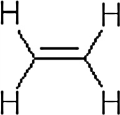

- Use the 1s orbital of hydrogen to form atomic orbitals for H₂ and draw the molecular orbital energy-level diagram. Label the energy levels with the MO symbols. Which of the following species of hydrogen would you predict to be stable based on your energy-level diagram? Explain (6 points).
H₂²⁺, H₂⁺, H₂, H₂–, H₂^{2–}
.

- Would water rise to the same height in a capillary tube made of polyethylene plastic as it does in a glass capillary tube of the same diameter? Polyethylene is a hydrocarbon, and glass is mostly silicon dioxide. Explain (3 points).

- CH₂F₂ has a dipole moment of 1.93 D and a boiling point of –52°C. CH₂Cl₂ has a dipole moment of 1.60 D and a boiling point of 40°C. Why is the boiling point of dichloromethane so much higher than that of difluoromethane (4 points)?

Temperature (K) | Pressure (torr)
65 | 130.5
70 | 289.5
75 | 570.8
80 | 1028
85 | 1718
- The vapor pressure of nitrogen at several different temperatures is shown: (15 points)
  - Make a linear graph.
  - Using points off your graph determine the equation of the best fit straight line.

  - Determine the heat of vaporization of nitrogen.

  - Determine the normal boiling point of nitrogen.

