Exam 4

Part 1: Multiple Choice (2 points each)

Directions: Please circle the best answer for each of the following questions.

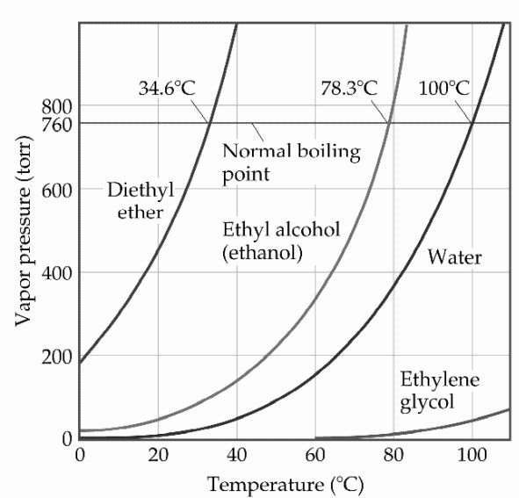
- Based on the figure above, the boiling point of diethyl ether under an external pressure of
0.855 atm is ________°C.
  - 0
  - 10
  - 20
  - 30
  - 40

- ______________ has the strongest intermolecular forces.
  - A2X, ΔHvap= 39.6 kJ/mol
  - BY2, ΔHvap= 26.7 kJ/mol
  - C3X2, ΔHvap= 32.5 kJ/mol
  - DX2, ΔHvap= 23.3 kJ/mol
  - EY3, ΔHvap= 21.6 kJ/mol

- Identify the technique that determines the arrangement of atoms and measures the distance between them.
  - x-ray diffraction
  - ultraviolet
  - nuclear magnetic resonance
  - infrared
  - atomic absorption

- Which of the following represent the addition polymer formed from: CH2=CH-CH3
  - 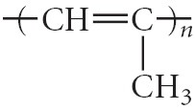
  - 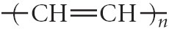
  - 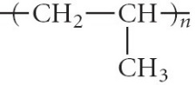
  - 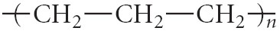

- Describe what happens when seawater is consumed to quench thirst.
  - Seawater can quench thirst once it is boiled.
  - Seawater quenches thirst when directly ingested.
  - Seawater draws water out of the body resulting in further dehydration and diarrhea.
  - Seawater helps diarrhea.
  - Seawater must be ingested at twice the volume to quench thirst.

- Which of the following compounds will be most soluble in ethanol (CH3CH2OH)?
  - trimethylamine (N(CH3)3)
  - acetone (CH3COCH3)
  - ethylene glycol (HOCH2CH2OH)
  - hexane (CH3CH2CH2CH2CH2CH3)
  - none of these compounds should be soluble in ethanol.

- In a reaction mixture containing only reactants, what is the value of Q?
  - -1
  - 1
  - ∞
  - 0
  - It cannot be determined without concentrations.

- Express the equilibrium constant for the following reaction: 10 N2(g) + 30 H2(g) ⇔ 20 NH3(g)
  - K = 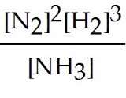
  - K = 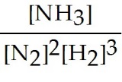
  - K = 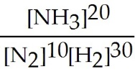
  - K = 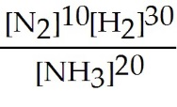
  - K = 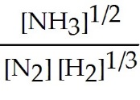

- What is Δn for the following equation in relating Kc to Kp?
C3H8(g) + 5 O2(g) ⇌ 3 CO2(g) + 4 H2O(l)
  - 3
  - 1
  - -3
  - 2
  - 6

- When using a pipet it is an acceptable technique
- to pipet by mouth because it provides the best suction and control.
- use a pipet without first conditioning it.
- suction the liquid below the calibration line and then add that to your reaction flask.
- suction the liquid above the calibration line and then add that to your reaction flask.
- none of the above

Part 2: Short Answer

Directions: Answer each of the following questions. Be sure to use complete sentences where appropriate. For full credit be sure to show all of your work.
- The vapor pressure of ethanol is 115 torr at 34.9 °C. If ∆H_{vap} of ethanol is 38.6 kJ/mol, calculate the temperature (in °C) when the vapor pressure is 101.325 kPa (8 points).
$$\ln\left(\frac{P_{2}}{P_{1}}\right)=\frac{-∆H_{vap}}{R}\left(\frac{1}{T_{2}}-\frac{1}{T_{1}}\right)$$
$$\ln\left(\frac{101.325 kPa}{115 torr}×\frac{760 torr}{101.325 kPa}\right)=\frac{-\left(38.6\frac{kJ}{mol}\right)}{\left(8.314\frac{J}{mol K}\right)}\left(\frac{1}{T_{2}}-\frac{1}{(34.9+273.15}\right)$$
$$\ln\left(\frac{101.325 kPa}{115 torr}×\frac{760 torr}{101.325 kPa}\right)=\frac{-\left(38.6\frac{kJ}{mol}\right)}{\left(8.314\frac{J}{mol K}\right)}×\frac{1000 J}{1 kJ}\left(\frac{1}{T_{2}}-\frac{1}{(308.05 K}\right)$$
$$\ln\left(6.608695652\right)=-\left(4642.771229 K\right)\left(\frac{1}{T_{2}}-0.003246226\frac{1}{K}\right)$$
$$1.888386305=-\left(4642.771229 K\right)\left(\frac{1}{T_{2}}-0.003246226\frac{1}{K}\right)$$
$$-0.000406737\frac{1}{K}=\left(\frac{1}{T_{2}}-0.003246226\frac{1}{K}\right)$$
$$0.002839489\frac{1}{K}=\frac{1}{T_{2}}$$
$$T_{2}=352.1760286 K-273.15=79 ℃$$
- A solution contains 3.5 moles of water and 1.5 moles of nonvolatile glucose (C₆H₁₂O₆) (8 points).
  - What is the mole fraction of water in this solution?
$$χ_{H_{2}O}=\frac{n_{H_{2}O}}{n_{total}}=\frac{3.5 mol}{3.5 mol+1.5 mol}=\frac{3.5 mol}{5.0 mol}=0.72$$
  - What is the vapor pressure of the solution at 25 °C, given that the vapor pressure of pure water at 25 °C is 23.8 torr?
$$P_{solution}=P^{°}χ_{solvent}=\left(23.8 torr\right)\left(0.72\right)=17 torr$$
- How does the sea of electrons model explain the high electrical conductivity of gold? How does band theory explain this (3 points)?
In the sea of electrons model valence electrons are delocalized throughout the metal. These model electrons are able to move electrical charge throughout the metal. In band theory the band gap between the valence band and conduction band is small, so it is easy for the electrons to move between the two bands. Applications of an electrical potential across a metal causes its mobile valance electrons to move toward the positive potential.
- Define triple point (3 points).
The temperature and pressure where liquid, solid, and gas are equally stable and are in equilibrium.
- Describe the difference between the conduction band and the valence band (3 points).
The valence band is the group of highest energy occupied orbitals in the solid. The conduction band is the set of empty orbitals that are higher in energy than the valence band. In metals the difference in energy between the valence band and conduction band is fairly small, making it easy for electrons to move from the valence band to the conduction band.

- An XRD analysis (λ = 154 pm) of a sample of copper has peaks at 2θ = 24.64° (n = 1), 50.54° (n = 2), and 79.62° (n =3). What is the distance (d) between layers of Cu atoms that could produce this diffraction pattern (8 points)?
$$d=\frac{nλ}{2sinθ}$$
$$d=\frac{(1)(154 pm)}{2 sin⁡(24.64°/2)}=\frac{154 pm}{(2)(0.2134)}=361 pm$$
$$d=\frac{(2)(154 pm)}{2 sin⁡(50.54°/2)}=\frac{308 pm}{(2)(0.4269)}=361 pm$$
$$d=\frac{(3)(154 pm)}{2 sin⁡(79.62°/2)}=\frac{462 pm}{(2)(0.6402)}=361 pm$$
d = 361 pm is the distance between Cu atoms that produced three peaks.

- Why is the ΔHvap higher than ΔHfus for a given compound (3 points)?
Vaporizing a substance requires the complete "breaking" of all intermolecular attractions, whereas the melting of a substance only requires the breaking of a portion of the intermolecular attractions.

- Determine the Henry's law constant for ammonia in water at 25°C if an ammonia pressure of 0.022 atm produces a solution with a concentration of 1.3 M (4 points).
$$S=kP⟹k=\frac{S}{P}=\frac{1.3 M}{0.022 atm}=59\frac{M}{atm}$$

- What happens to a supersaturated solution of potassium acetate once it is cooled and a small crystal of solid potassium acetate is added (3 points)?
The portion of potassium acetate that was dissolved beyond its normal solubility, will precipitate out of the solution. The solution will now be saturated.

- Is the following statement true or false? For solutions of the same reverse osmotic pressure at the same temperature, the molarity of a solution of NaCl will always be less than the molarity of a solution of CaCl₂. Explain your answer (3 points).
False, the molarity of the NaCl solution would be greater by 1.5 times than the molarity of CaCl₂.

- Explain why a needle floats on the surface of water but sinks in a container of methanol, CH₃OH (3 points).
A needle floats on water but not on methanol because of the high surface tension of water. This is because water can hydrogen bond through two O-H bonds with other water molecules, whereas methanol has only one O-H bond through which to form strong hydrogen bonds.

- Explain why pipes filled with water are in danger of bursting when the temperature drops below 0 °C (3 points).
The expansion of water in the pipes on freezing may create sufficient pressure on the wall of the pipes to cause them to burst.

- Explain what happens to a substance when it is heated in a closed container to its critical temperature (3 points).
As the temperature rises, more liquid vaporizes and the pressure within the container increases. As more and more gas is forced into the same amount of space, the density of the gas becomes higher and higher. At the same time, the increasing temperature causes the density of the liquid to become lower and lower. At the critical temperature, the meniscus between the liquid and gas disappears and the gas and liquid phases commingle to form a supercritical fluid.

- Consider the following reaction at equilibrium (5 points).
4 FeS2 (s) + 11 O2 (g) ⇌ 2 Fe2O3 (s) + 8 SO2 (g)
  - What will happen if FeS2 is added to the reaction?
No change
  - What will happen if O2 is added to the reaction?
The equilibrium will change in the direction of the products.
  - What will happen if Fe2O3 is added to the reaction?
No change in equilibrium is observed.
  - What will happen if the pressure increased?
The equilibrium will change in the direction of the products.
  - What will happen if the volume increased?
The equilibrium will change in the direction of the reactants.

- A 50.0 L reaction vessel contains 1.00 mol of nitrogen gas, 3.00 mol of hydrogen gas, and 0.500 mol of ammonia. Will more ammonia be formed or will it dissociate when the mixture goes to equilibrium at 400 °C (8 points)?
N_{2 (g)} + 3 H_{2 (g)} $⇌$ 2 NH_{3 (g)} K_{c} = 0.500
$Q_{c}=\frac{{\left[{NH}_{3}\right]}^{2}}{\left[N_{2}\right]{\left[H_{2}\right]}^{3}}=\frac{{(0.0100)}^{2}}{\left(0.0200\right){(0.0600)}^{3}}=23.1$
Since Q_{c} > K_{c}, the reaction will go to the left as it approaches equilibrium. So, the ammonia will dissociate.

- At high temperatures, a dynamic equilibrium exists between carbon monoxide, carbon dioxide, and solid carbon. At 850 °C, K_{c} is 0.153 (12 points).
C _{(s)} + CO_{2 (g)} $⇌$ 2 CO _{(g)} ∆H° = 172.5 kJ
  - What is the value of K_{p}?
$$K_{p}=K_{c}{\left(RT\right)}^{Δn}$$
$$K_{p}=\left(0.153\right){\left[\left(0.0821 \frac{L atm}{mol K}\right)\left(850 ℃+273\right)\right]}^{\left(2-1\right)}$$
$$K_{p}=14.1$$
  - If the original reaction system consisted of 1.00 g of carbon and 1.50 atm of carbon dioxide, what are the pressure of carbon dioxide and carbon monoxide when equilibrium is established?
C _{(s)} + CO_{2 (g)} $⇌$ 2 CO _{(g)}

I 1.00 g 1.50 atm 0.00 atm
C n/a -x +2x
E n/a 1.50 atm – x +2x
F n/a 1.50 atm – 1.14 atm = 0.36 atm 2(1.14 atm) = 2.28 atm
$$K_{p}=\frac{P_{CO}^{2}}{P_{CO_{2}}}$$
$$14.1=\frac{{\left(2x\right)}^{2}}{\left(1.50 atm-x\right)}$$
$$\left(14.1\right)\left(1.50 atm-x\right)=4x^{2}$$
$$4x^{2}+14.1x-21.2 atm=0$$

use the quadratic formula: $x=\frac{-b±\sqrt{b^{2}-4ac}}{2a}$
$$x=\frac{-14.1 ±\sqrt{{(14.1)}^{2}-4\left(4\right)(-2.12)}}{2(4)}$$
$$x_{+}=1.14 x_{-}=-4.66$$
The value of -4.66 does not make sense and can be discarded. So x = 1.14
Filling in value for x in the above table, it is found that the partial pressure of carbon dioxide is 0.36 atm and the partial pressure of carbon monoxide is 2.28 atm at equilibrium.

  - How will the equilibrium pressure of carbon monoxide change if the temperature is decreased?
This is an endothermic reaction, so if the temperature is decreased the reaction will shift to the left. Since carbon monoxide is a product its equilibrium pressure will decrease.

