Quiz 9

Directions: Answer each of the following questions. Be sure to use complete sentences where appropriate. For full credit be sure to show all of your work. Where appropriate answers should be boxed for clarity, written to the correct number of significant figures, and, include the proper units.
- Why is it observed that water droplets are spherical in outer space (3 points)?
Water droplets are spherical in outer space because the outer water molecules experience the pull from the inner water molecules and there is no gravity to pull the water droplet into a teardrop shape as is observed on Earth.

- Two liquids – one polar, one nonpolar – have the same molar mass. Which one is likely to have the higher boiling point? Explain your answer (3 points).
The polar liquid will most likely have the higher boiling point because it will experience both London-dispersion forces and dipole forces.

- Identify each as an atomic, metallic, covalent network, ionic, or molecular solid (5 points).
  - CO_{2 (s)} _________molecular solid
  - Xe _{(s)} _________atomic solid
  - NaCl _{(s)} _________ionic solid
  - Ag _{(s)} _________metallic solid
  - C _{(s)}, diamond _________covalent network solid

- Sketch a phase diagram for element X, which has a triple point of 152 K and a pressure of 0.371 atm, a boiling point of 166 K at a pressure of 1.00 atm, and a normal melting point of 161 K (5 points).
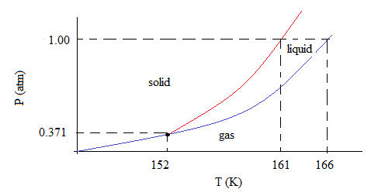
- What is the two-point Clausius-Clapeyron Equation (2 points)?
$$\ln\left(\frac{P_{2}}{P_{1}}\right)=\frac{-∆H_{vap}}{R}\left(\frac{1}{T_{2}}-\frac{1}{T_{1}}\right)$$

- What is the solvent in the colligative properties experiment (2 points)? ___lauric acid

