Exam 3

Part 1: Multiple Choice (2 points each)

Directions: Please circle the best answer for each of the following questions.

- Safety goggles must be worn when
- you are using chemicals.
- anyone is using flames.
- anyone is using chemicals.
- if my teacher is wearing them.
- all of the above

- A ligand is any _______ forming a coordinate bond to a metal cation.
  - Lewis acid
  - ion
  - Lewis base
  - organic compound
  - species

- Which ligand below is not correctly named?
  - H₂O, hydro
  - NH₃, ammine
  - CN⁻, cyano
  - CO, carbonyl
  - OH⁻, hydroxo

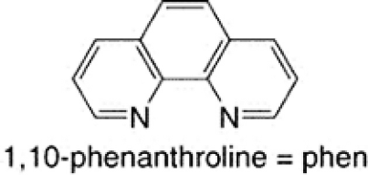
- 1,10-phenanthroline, which is shown below, is an example of a ________ ligand.
  - monodentate
  - bidentate
  - tridentate
  - good
  - poor
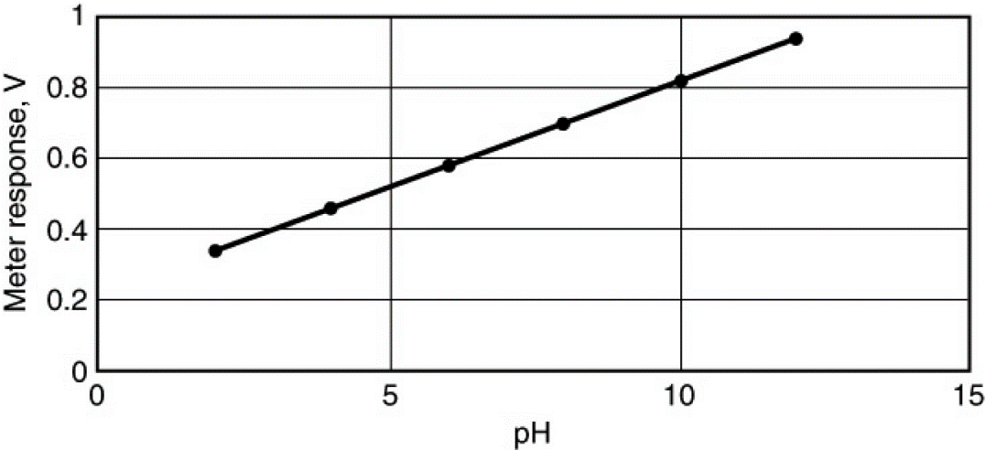
- A pH meter uses an electrode arrangement that provides a voltage that depends on [H⁺], in accord with the Nernst equation. The following plot illustrates this dependence. What effect would changing temperature have on the measurement and this plot?
  - A change of temperature would have no effect.
  - An increase in temperature would increase the slope.
  - An increase in temperature would decrease the slope.
  - An increase in temperature would increase the y intercept.
  - An increase in temperature would decrease the y intercept.
- For an octahedral complex what metal d orbitals are directly towards the ligand?
  - d_{xy}, d_{xz}
  - d_{xy}, d_{xz}, d_{yz}
  - $d_{z^{2}}, d_{x^{2}-y^{2}}$
  - $d_{z^{2}}, d_{xz}, d_{yz}$
  - none of the above

- The unit of current, ampere (A), is defined as ________
  - 1 C.
  - 1 C/s.
  - 1 mol of electrons.
  - 10 C/s.
  - 96,500 C/s.

- The standard cell potential for the nickel–cadmium battery is 1.35 V, and the cell reaction can be written as
2 NiO(OH) (s) + 2 H₂O (l) + Cd (s) → 2 Ni(OH)₂ (s) + Cd(OH)₂ (s)
Which one of the following statements do you expect to be true based on the Nernst equation? Note Q = reaction quotient, and K = equilibrium constant for the cell reaction.
  - As the battery is used, the cell voltage approaches zero because Q approaches K, in value.
  - When the battery no longer works, the cell voltage is zero because Q = K.
  - As the battery is used, the cell voltage does not change because Q equals 1.
  - When the battery is fully charged, Q > K.
  - When the battery is fully charged, Q < K.
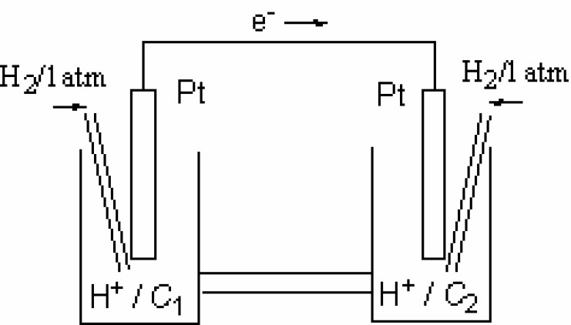
- Which statement about this concentration cell is incorrect?
  - The electrode on the left side is the anode.
  - The electrode on the left side is the electron.
  - Anions in the salt bridge migrate to the left side.
  - Hydrogen ions are reduced on the right side.
  - The pH of the solution on the right side is higher than the pH on the left side.

- Which statement about corrosion is not correct?
  - Corrosion is promoted by the presence of water.
  - Corrosion is promoted by the presence of electrolytes.
  - Corrosion is promoted by contact between dissimilar metals.
  - Surface oxidation protects metals such as iron, stainless steel, and aluminum from corrosion.
  - Cathodic protection prevents corrosion of an object by attaching it to a metal that serves as the cathode of the resulting electrochemical cell.

Part 2: Short Answer

Directions: Answer each of the following questions. Be sure to use complete sentences where appropriate. For full credit be sure to show all of your work.
- What determines whether a transition metal ion is in a high-spin or a low-spin electron configuration (3 points)?

- Briefly account for each of the following observations (4 points):
  - Atomic radii decreases in the order Sc > Ti > V

  - Densities increase in the order Ti < V < Cr

- Although Cl⁻ is a weak-field ligand and CN⁻ is a strong-field ligand, [CrCl₆]³⁻ and [Cr(CN)_{6 ]}³⁻ exhibit approximately the same amount of paramagnetism (7 points).
  - Explain.

  - Name each complex.

  - What is the geometry around each ion? ________________________
- The Ni²⁺ _{(aq)} cation is green, but Zn²⁺ _{(aq)} is colorless. Explain (4 points).

- Draw all possible diastereoisomers of [Cr(C₂O₄)₂(H₂O)₂]⁻. Which can exist as a pair of enantiomers (6 points)?

- In water, the titanium(III) ion, in hexaaquatitanium(III), has a broad absorption band at 500 nm (10 points).
  - What color light is absorbed by the ion? ____________
  - What color light is transmitted by the ion? ____________
  - What the formula of the ion? ____________
  - Calculate the crystal field splitting energy, Δ, in kJ/mol.

- Would you expect the following compounds to have cis-trans isomers, mer-fac isomers, or no geometric isomers (5 points)?
  - [CuCl₂Br₂]²⁻ ________________________
  - [Fe(NH₃)₅Cl]²⁺ ________________________
  - [Ti(H₂O)₄(OH)₂]²⁺ ________________________
  - [Co(NH₃)₃Cl₃] ________________________

- The anode in an electrochemical cell is defined as the electrode where oxidation takes place. Why is the anode in an electrolytic cell connected to the positive (+) terminal of an external supply, whereas the anode in a voltaic cell battery is connected to the negative (-) terminal (5 points).

- The following cell reactions occur spontaneously (8 points):
B + A⁺ → B⁺ + A
C + A⁺ → C⁺ + A
B + C⁺ → B⁺ + C
- Arrange the following reaction half-reactions in order of decreasing tendency to occur: A⁺ + e⁻ → A, B⁺ + e⁻ → B, C⁺ + e⁻ → C.

- Which of these substances (A, A⁺, B, B⁺, C, C⁺) is the strongest oxidizing agent? ______
- Which is the strongest reducing agent? ______
- Which of the three cell reactions delivers the highest voltage? ______________________
- A current of 15.0 A electroplated 50.0 g of hafnium metal from an aqueous solution in 2.00 hours. What was the oxidation number of hafnium in the solution (8 points)?

- An electrochemical cell is based on the following two half-reactions:
Use the following reduction potentials in the problems below:
MnO₄⁻ _{(aq)} + 4 H⁺ _{(aq)} + 3 e⁻ → MnO_{2 (s)} + 2 H₂O _{(l)} E° = 1.68 V
Pb²⁺ _{(aq)} + 2 e⁻ → Pb _{(s)} E° = -0.13 V

Red: MnO₄⁻ _{(aq)} (1.50 M) + 4 H⁺ _{(aq)} (2.0 M) + 3 e⁻ → MnO_{2 (s)} + 2 H₂O _{(l)}
Ox: Pb _{(s)} → Pb²⁺ _{(aq)} (0.10 M) + 2 e⁻
Calculate the cell potential at 25 °C (8 points).

- The following half-reactions that when combined result in a spontaneous reaction conditions (12 points):
NO₃⁻ _{(aq)} + 4 H⁺ _{(aq)} + 3 e⁻ NO _{(g)} + 2 H₂O _{(l)} E° = +0.96 V
Hg₂²⁺ _{(aq)} + 2 e⁻ 2 Hg _{(l)} E° = +0.79 V
- Determine the net ionic equation and the standard cell potential.

- Write the cell notation for the reaction. ____________________________________
- Calculate the ΔG°.

