Spring 2013 MATH 160 Midterm #1 Form B-1 (chapters 1- 6) 500 points

Name:

Instructions: May use 1 page of notes (writing or typing back and front is okay), formula pull out card and graphing calculator are also allowed.

1) The accompanying Histogram displays the results of a Statistics Midterm.

- Look at the histogram to determine the class midpoints and frequency, then fill out the table.
Class midpoints | Frequency

- How many students took the exam?

- What was the MEAN score?

- What percentage of students earned more than 80 points on the Midterm?
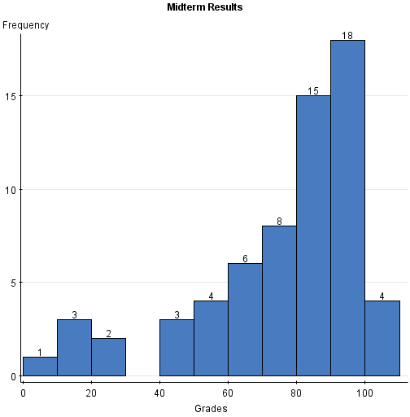
2) (Round answers to tenths place when appropriate)
The given frequency distribution lists the hours of sleep per night in the month of December for a random sample of students during final exams.
# of hours of sleep | Frequency | Class Midpoints
0-2 | 5
3-5 | 20
6-8 | 10
9-11 | 3

- Complete the table by finding the class midpoints.

- Find (give the numerical answer)

- What is the class width?

- Find the mean number of hours students are sleeping per night.

- Find the standard deviation for the number of hours students are sleeping per night.

- According to the 2010 National Health Statistics Reports, the weight of male babies less than 2 months old in the U.S. is normally distributed with mean 11.5 pounds and standard deviation 2.7 pounds. What percentage of babies weigh more than 13 pounds?

- An ABC News report stated that the mean distance that commuters in the U.S. travel each way to work is 16 miles. Assume the standard deviation is 8 miles and that the distances are normally distributed. A sample of 75 commuters is chosen,

- What is the probability that the sample mean commute distance is between 18 and 20 miles? (round your FINAL answer to 4 decimal places)

- Is this an unusual probability? Explain using the rule for determining unusual probabilities.

- The U.S. Energy Information Agency reported that the mean monthly household electric bill in the U.S. in 2007 was $99.70. Assume the amounts are normally distributed with a standard deviation of $20. A local energy company is giving customers a rebate if they have an electric bill that falls in the bottom 5% of all electric bills. Find the dollar amount of the bill that separates those customers that will receive the rebate from those customers who will not. ( Round your FINAL answer to the nearest cent)

(Write out appropriate calculator commands and round answer to 3 decimal places)

6) The National Health and Nutrition Survey reported that 30% of adults in the United States have hypertension (high blood pressure). A sample of 20 adults is studied.

- What is the probability that exactly 4 have hypertension?

- What is the probability that at least 4 have hypertension?

- What is the probability that at most 4 have hypertension?

The National Health and Nutrition Survey reported that 30% of adults in the United States have hypertension ( high blood pressure).

- What is the mean number who have hypertension in a sample of 20?

- What is the standard deviation of the number who have hypertension in a sample of 20?

7) The ELISA test is used to screen blood for the presence of HIV. Like most diagnostic procedures, the test is not foolproof. When a blood sample contains HIV, the ELISA test will give a positive result 99.6% of the time. When the blood does not contain HIV, the ELISA test will give a negative result 98% of the time. In a sample of 100,000 people, the following results were published.
If one of the 100,000 subjects is randomly selected, find the probability that (Leave your answer as a fraction)

- The ELISA test gives a negative result and the person has HIV.

- The person has HIV given that they tested negative.

- The ELISA test gives a positive result or the person has HIV.

In Reality

ELISA test results | Person has HIV | Person does not have HIV | Total
Positive | 498 | 1,990 | 2,488
Negative | 2 | 97,510 | 97,512
Total | 500 | 99,500 | 100,000

- A local casino accessible from the interstate is introducing a drive-through service where players can try their luck with games that last under one minute. In one of these games, a player must select a card from a well-shuffled deck of 52 cards.

- What is the probability of drawing a Heart or a Queen? (Round answer to the thousandths place)

- Based on your answer is it unusual that you will draw a Heart or a Queen? Explain using the rule for unusual probabilities.

- Are the two events disjoint (in other words are the two events mutually exclusive)? EXPLAIN YOUR ANSWER.
9) FICO Credit Rating Scores
( Round your answers to the hundredths place when appropriate)

When you apply for credit lenders want to know what risk they'd take by loaning money to you. FICO scores are the credit scores most lenders use to determine your credit risk. FICO scores range from 300 to 850. The accompanying table shows the probability distribution for x, the number of loans an individual with a FICO score of 700 has. (Fill in the missing probability and answer the questions below)

X | 0 | 1 | 2 | 3 | 4
P(X) | .10 | .25 | ? | .20 | .04

  - What is the probability that an individual with a FICO score of 700, has two loans?

  - Find the mean and standard deviation of the probability distribution above.

  - Is it unusual for an individual with a FICO score of 700 to have 4 loans? EXPLAIN using the rules for unusual probabilities. Do not just give a yes/no answer.

- Each state in the U.S. can charge its own tax on gasoline. The boxplots show the gas tax (in cents per gallon) for the 50 states by region.

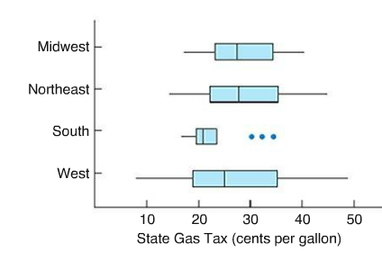
Compute the Interquartile Range (IQR) of each region.
Midwest IQR =
Northeast IQR =
South IQR =
West IQR =

Based on the IQR above which state has the least variable State Gas Tax?

Note: Your answers will be estimates ( make sure to line up the boxplot with the numbers on the horizontal axis). Don’t just give me a number for the IQR, make sure that you write out the numbers that helped you get the IQR.

