# [image]Review for Exam 5, Chapter 9 & 10

# Sections 9.1-9.6, 10.1-10.3

**Math 110, Vanden Eynden**

1. Find  and  given  and 

2. a. Graph . Plot at least 4 points accurately.

b. Graph . Plot at least 4 points accurately.

3. Find the inverse of each function:

a.  b.  c. 

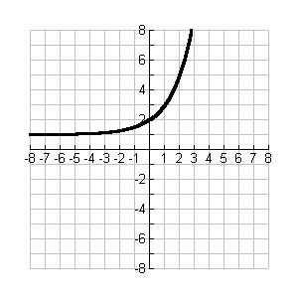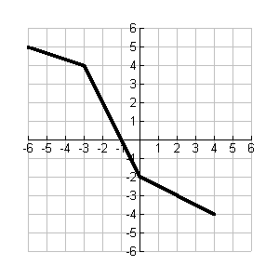4. On each graph of *g*(x) below, graph the inverse function, , on the same set of axes.

5. Which of the following are graphs of one-to-one functions? Circle the one-to-one functions.

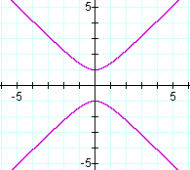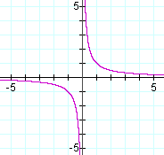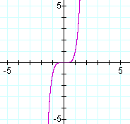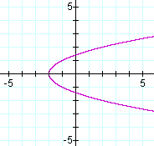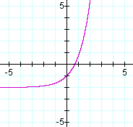

6. Simplify.

a.  b.  c. 

d.  e.  f. 

7. Express as a single logarithm and simplify if possible. 

Solve for x. Where appropriate, include approximations to 4 decimal places.

8.  9. 

10.  11. *x* =

12.  13. 

14.  15. 

16.  17. 

18. Find  using the change of base formula. Round to 4 decimal places.

19. Classify each equation as a parabola, a hyperbola, a circle, or an ellipse:

1. 
2. 
3. 
4. 
5. 

20. Given the equation 

1. 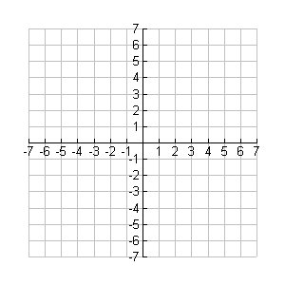Find vertex (h,k)
2. Find axis of symmetry
3. Find x intercepts
4. Find y intercepts
5. Graph the parabola

21. Given the equation , convert to standard form and graph the circle.

22. Given the equation 

1. Convert to standard form by completing the square (twice)
2. Find the center *(h,k)* and radius *r*
3. Graph the circle

23. Find the equation of the circle with center (3,-2) and radius of 4.

24. Given the equation 

1. Convert to standard form of an ellipse.
2. Find the x-intercepts 
3. Find the y-intercepts 
4. Graph the ellipse

25. Given the equation 

* 1. Find the center and the vertices on the major and minor axes.
  2. Graph the ellipse.

26. Given the equation 

1. Convert to standard form
2. Find and .
3. Does your hyperbola open up/down or sideways?
4. What are the vertices?
5. Draw your “box” and find the asymptotes: 
6. Graph the hyperbola.

**More** Conic Section graphing practice: Graph the following equations.

27.  28.  29. 

****Name the vertex. Name the center and radius Name the center and radius

30.  31.  32. 



33. 



**FORMULAS from Chapters 9 & 10:**

1. Composition of functions:



1. Properties of Logarithms:
2.   
3. 
4. 
5. 
6. 
7. 
8. 
9. Equation of a parabola:
   1. (Regular up/down) Parabola of the form :

Vertex:  and  (plug *x* coordinate into equation to get *y* coordinate)

* 1. (Sideways) Parabola of the form :

Vertex:  and  (plug *y* coordinate into equation to get *x* coordinate)

* 1. Parabola of the form :

Vertex: 

* 1. Parabola of the form :

Vertex: 

1. Equation of a Circle:
   1. Centered at the origin:
   2. Not centered at the origin:  where is the center and is the radius
2. Equation of an Ellipse:
   1. Centered at the origin: 
   2. Not centered at the origin: 
3. Equation of a Hyperbola centered at the origin.
   1. Opening sideways: 
   2. Opening up/down: 

# Screen Shot 2012-11-28 at 8.05.17 PM.png**SOLUTIONS** Review for Exam 5, Chapter 9 & 10

**Math 110, Vanden Eynden**

1. 



2. a. 

|  |  |
| --- | --- |
| x | y |
| -2 | 4 |
| -1 | 2 |
| 0 | Screen Shot 2012-11-28 at 8.43.32 PM.png1 |
| 1 | 0.5 |
| 2 | 0.25 |

b.  same as 

|  |  |
| --- | --- |
| x | y |
| 0.25 | -2 |
| 0.5 | -1 |
| 1 | 0 |
| 2 | 1 |
| 4 | 2 |

3. a.  b.  c. 

4. 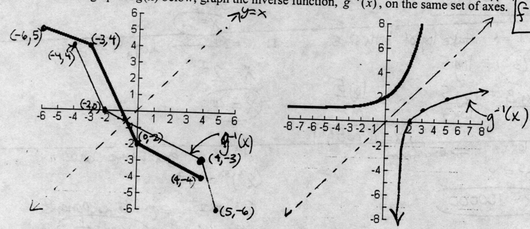

5. 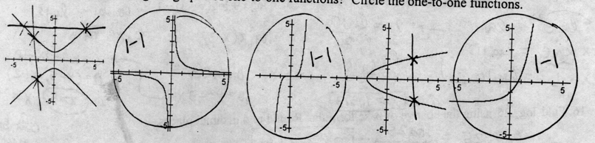

6. a. x = ­–1 b. x = ½ c. x = 3 d. x = 5 e. x = 0 f. x = –1

7. 

8. Change to exponential form: 

9. Get same base: x = 2

10 Take log of both sides: 

11. Simplify logarithm: x = 4

12. Change to exponential form: 

13. Get same base: x = ½

14. Take “ln” of both sides: 

15. Combine logs, then change to exponential form: x = 5, (note:)

16. Change to exponential form: 

17. Combine natural logs on the left, then eliminate the ln’s: 

18. 

19. a. parabola b. hyperbola c. circle d. circle e. ellipse

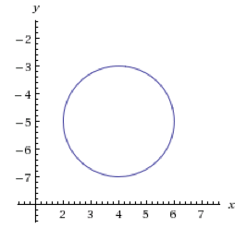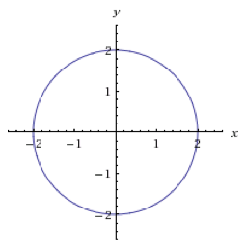20. a. (–4,–3) b. y = –3 c. (5, 0) d. (0, –1), (0, –5) e. see graph

21.  see graph 🡪

22. a. 

b. center (4, –5), r = 2

c. see graph 🡪

23. 

24. a.  b. (2, 0), (–2, 0) c. (0, 4), (0, –4) d. see graph

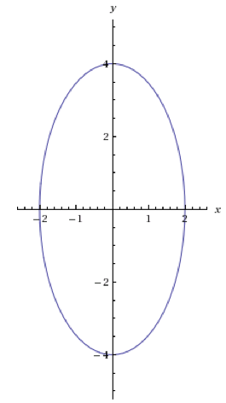

25. a. center (2, 1), go 3 to right and left (5, 1), (–1, 1),

go 2 up and down (2, 3), (2, –1)

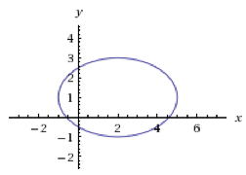 b. see graph

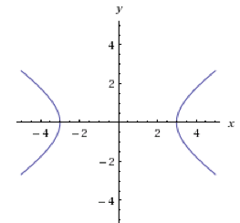26. a.  b. a = 3, b = 2 c. sideways d. (3, 0), (–3, 0)

e.  f. see graph