1. 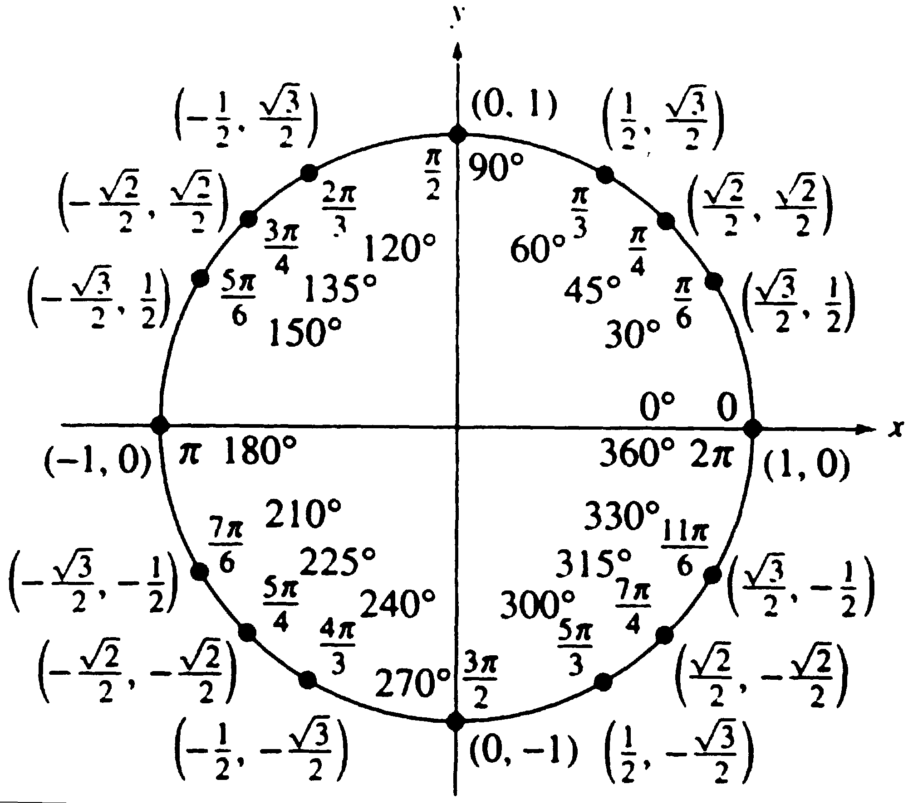

All +

**sin, csc**

**cos, sec**

**tan, cot**

1. cosx, sinx: 

tanx, secx: 

cotx, cscx: 

4. a.  b. -1 c. 0 d. 2.30475 e. undefined f.  g. 1.30541 h.  i. -1 j. -2.18504 k. 0.08716 l. 5

m.  n. 

o.  p. 

5. 

12



5

ϴ

6.



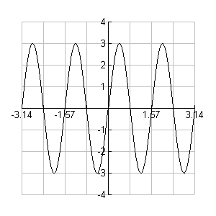7. amp=3, period = π/2, no phase shift

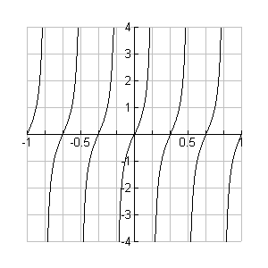8. period = 1/3

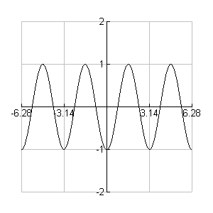9. amp=1, period=π, phase shift: right π/2

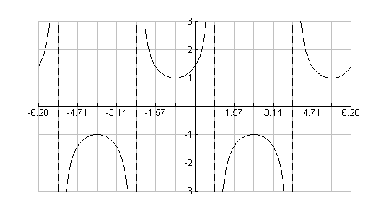10. period=2π, phase: left π/4

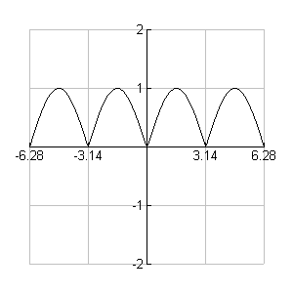11. amp=1, period=π

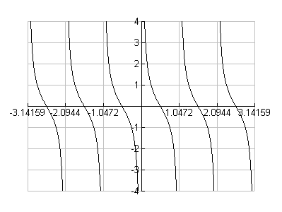12. period= π/3, phase: left π/3

13. a= 4, period = 



14. 

15. (answers vary)





16. 

17.



18. 



19. 

*30*

*120*

*x*

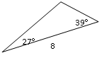20. ASA 114°

3.98

5.51

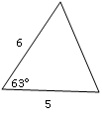21. SAS

50°

5.81

67°

22. SSS

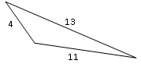

52°

111°

17°

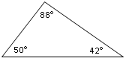23. AAA Not unique! Infinite solutions

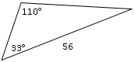24.AAS

32.5

37°

35.9

25. C

8 5 5

A 25° B

B’

 or 

 

 

26. x = 57.4 m

100

x

35°

27. x = 5098.8 ft

x 16500

18°