**Math 280: 11.9 Representations of functions as Power Series**

**The Geometric Power Series centered at *x* = 0**

 R = 1

This one power series can lead us to an infinite number of OTHER power series representations.

Express the following functions as power series.

1. 

2. 

3. 

**Differentiation and Integration of Power Series**

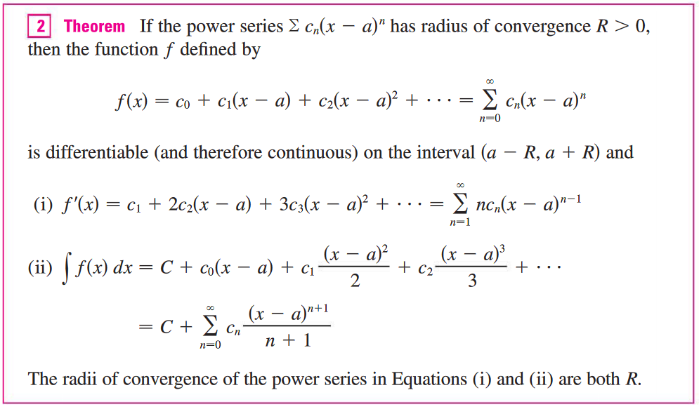

Express the following functions as power series. Don’t forget to find the constant term, C, if needed.

1. 

2. 

3. 