Cultural Geography 130

Course Syllabus

Geography Department
Grossmont College
Spring 2015

"Our culture is the sea in which we swim, as transparent to us
as the ocean is to the fish that live in it." -George Hein, 1998
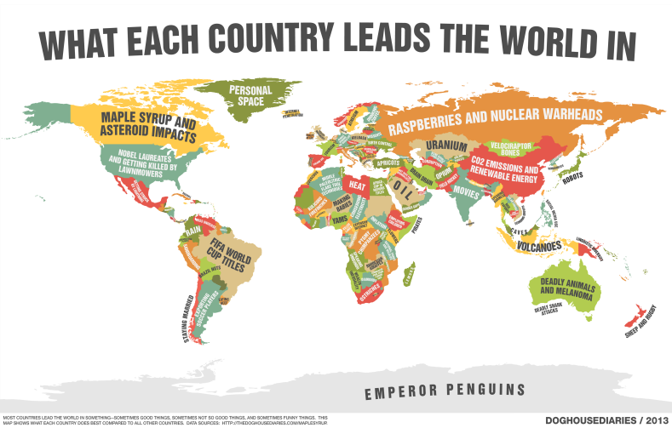
WHAT EACH COUNTRY LEADS THE WORLD IN

Instructor: Scott Therkalsen
E-mail: scott.therkalsen@gcccd.edu
Class Website: www.grossmont.edu/people/scott-therkalsen
Class meets: M/W 12:30-1:45 in Room: 36-354
Office Hours: Wed 11:00-12:30; Tues 3:30-7:00; Thurs 11:30-12:30 and by appointment
Office: Building 37 room 300-A4
Phone: (619) 644 7358

REQUIRED TEXT and MATERIALS:
James Rubenstein. An Introduction to Human Geography: the cultural landscape. (ninth edition). Person-Prentice Hall. 2007. ISBN: 978-0-13-243573-4

Quinn, Daniel. Ishmael: an adventure of the mind and spirit. Bantam/Turner books. ISBN: 0-553-37540-7
AND
Internet Access: Students are required to have access to the internet for this course. Utilizing this cultural geography online webpage is a vital tool for success:
www.grossmont.edu/scotttherkalsen
**If you need assistance accessing a Grossmont College internet account contact your instructor at the beginning of the course

Suggested text:
Veregin, Howard. 2005 (or newer). Goodes’s World Atlas. Latest Edition. Rand McNally and Company.

Introduction
Welcome to Cultural Geography 130! You’ve chosen an exciting time to begin your study of the human landscape. The world is changing, physically and socially, at an unprecedented pace. Our goal throughout this course is to make sense of how the places of the world came to exist as we know them and how they are continuing to change. This class is designed to cultivate your understanding of the world through the use of geographic concepts. I encourage all of you to come to class prepared to speak with and interact with each other on a daily basis. Taking responsibility for your actions and working hard to learn and enjoy this course will ensure that we all grow as citizens of the world and accomplish our goals.

Course Description
This course is designed to enable the success of every type of learner. It combines lecture, in-class discussions and activities, group work, and a variety of assessment techniques to ensure your full comprehension of the material. Material covered in lecture and readings will be reinforced through in-class activities. Concepts of cultural geography will build upon one another as we progress through the semester ending with your ability to explain and assess the major human geography concepts present in different regions throughout the globe. Students are expected to read and write at a proficient college level and actively apply concepts learned in class to real world situations.

Catalog Description
“An exciting course examining the role of culture and the physical environment in shaping the world’s major regions and landscapes. Special attention will be given to the diffusion of religions and languages, population dynamics, food production and ways of living, geopolitical conflicts, and human-environmental interactions to better relate these cultural factors to current international events and problems.”

Student Learning Outcomes
Mastering the topics above will enable you to:
- Identify and differentiate physical and cultural features on a map;
- Students should be able to memorize, apply, and explain the rationale behind classification systems developed for recognizing, explaining, and predicting relationships, patterns, and trends in Cultural Systems (e.g., the demographic transition; classification of languages; classification of religious systems; human development index; genetic classification system of boundaries; state territorial morphology; etc.)
- Critically analyze current and historical cultural concepts effecting different regions of the world and the inter-relationships between these regions;
- Follow and effectively scrutinize current events geographically.

Explanation of Assignments
Exams (60%):
There will be two exams covering sectional material and one final covering all material (75% new and 25% old material). Exams will consist of multiple choice, true and False, and short essay sections. You must bring a “Datalink” form #26760for each test. There will be no make-up for missed tests.

Map Quizzes (22%)
There will be a total of four map quizzes. They will cover the Western Hemisphere, Europe and the Middle East, Africa, and Asia respectively. They will be worth roughly 5% each for a total of 21%. There will be no make-up for missed quizzes.

Research Paper (8%):
There will be one research paper reinforcing concepts learned in class. It will follow the migration of your family integrating concepts of ethnicity, religion, population, language, migration and other pertinent geographic issues. The paper will be assessed for the information presented as well as grammar, syntax, and organization (more information will be provided at a later date).

Current Concept Assignments (10%):
The remainder of your grade will consist of homework assignments, the majority of which will be “Current Topic Assignments” Starting soon each week you will be responsible to investigate current events that have taken place in the world as they relate to current class concepts. You must fully complete each of the event assignments handed out in class and turn them in on time for full credit; NO LATE ASSIGNMENTS WILL BE ACCEPTED (More information to come soon).

*Note: there is NO extra credit offered – plan accordingly.

ASSESSMENT:
Assessment was created to provide students with different abilities to demonstrate their knowledge in a variety of manners.
Assignment Points Possible % of Total Grade
Map Quiz One 20 points ~5%
Map Quiz Two 20 points ~5%
Map Quiz Three 20 points ~5%
Map Quiz Four 20 points ~5%
Map Quiz Totals 80 points ~22%
Exam One 70 points ~19%
Exam Two 70 points ~19%
Exam Three 70 points ~19%
Exam Totals 210 points ~60%
Family Migration Paper 30 points ~8%
Current concept assignments 35 points ~10%
Total Points Possible 355 points 100%

MQ1_____ + MQ2_____ + MQ3_____ + MQ4_____ + E1______ + E2______ + E3______
+ FRP______+ CCA______ + =Total________/355
Grading Scale
A 90-100% 320 points and up
B 80-89% 284-319 points
C 70-79% 248-283 points
D 60-69% 213-247 points
Failing 59% and below 213 and below
Credit/No Credit 70-100% for credit 248 and above

**You should actively track your grades at the website: www.eclassinfo.com
To login: username is your Grossmont ID
Your password is your 6 digit birthday
GENERAL POLICIES:
Attendance and Behavior
Inappropriate behavior of any kind in the classroom will not be tolerated. You are expected to come to every class prepared and ready to work. Students may be dropped from class for failure to attend the first week or for excessive absences. If necessary it is your responsibility to officially withdraw from the course before the final drop deadline.
The most important strategy for succeeding in this course is to come to class eager to learn, participate and critically think. There will be no makeup quizzes or exams. No late assignments will be accepted. As adults you are expected to respect your classmates by coming to class on time, acting appropriately and refraining from using any electronic devices during class; students with cell phones visible during class will be asked to leave (voice recorders and electronic translators may be used with permission but no electronic translators may be used during tests).

Preparation for Class
Students should always bring a pencil/pen, colored pencils, 3 ring binders and their textbook to every class meeting. Readings listed in the course schedule should be completed prior to the class meeting and prior notes should be reviewed and questions generated prior to each class meeting. The class website should be visited weekly and the current lecture topic should be reviewed. These actions will insure that you will be well prepared to actively participate in discussions and class activities.

Behavior and Academic Integrity
“Cheating and plagiarism (using as one’s own ideas, writings or materials of someone else without acknowledgement or permission) will result in any one of a variety of sanctions. Such penalties may range from an adjusted grade on the particular exam, paper, project or assignment (all of which may lead to a failing grade in the course) to, under certain conditions, suspension or expulsion from a class, program or the college. For further clarification and information on these issues, please consult with your instructor or contact the office of the Associate Dean of Student Affairs.”

Students with Disabilities
“Students with disabilities who may need accommodations in this class are encouraged to notify the instructor and contact Disabled Student Programs and Services (DSPS) early in the semester so that reasonable accommodations may be implemented as soon as possible. Students may contact DSPS in person in Room 110 or by telephone at (619)644-7112 or (619)644-7119 (TTY for deaf).”

Supervised Tutoring Referral
Students are referred to enroll in the following supervised tutoring courses if the service indicated will assist them in achieving or reinforcing the learning objectives of this course:
English 198W, Supervised Tutoring for assistance in the English Writing Center (Room 70-119); and/or IDS 198T, Supervised Tutoring to receive one-on-one tutoring in academic subjects in the Tutoring Center (Room 70-229, 644-7387).

CLASS SCHEDULE
*This is only a tentative schedule; you will be notified of any changes as they occur throughout the semester
DATES | CONCEPTS | RUBENSTEIN (11th) & QUINN READINGS | ASSIGNMENTS/ ASSESSMENT
01/26/2015 | Introductions
01/28/2015 | Geographic Tools | Pgs: 10-23
02/02/2015 | Origins of Culture | Readings in handout packet
02/04/2015 | Globalization and Population
02/09/2015 | Population Patterns | Chapter Two
02/11/2015 | Population Theories |  | MAP QUIZ ONE
2/16/2015 | NO SCHOOL |  | NO SCHOOL
02/18/2015 | Population Issues | Chapter Three
02/23/2015 | Migration Patterns
02/25/2015 | TEST ONE | STUDY! | TEST ONE
03/02/2015 | Language Distribution
03/04/2015 | Language Relationships | Chapter Five
03/09/2015 | Writing and Religious Origins
03/11/2015 | Religious Distribution | Chapter Six
03/16/2015 | Religions Conflicts |  | MAP QUIZ TWO
03/18/2015 | Ethnicity
3/23-3/27 | SPRING BREAK |  | NO CLASS
03/30/2015 | Political Boundaries | Skim Chapter Seven
04/01/2015 | Political Geography
04/06/2015 | Political Hotspots | Chapter Eight
04/08/2015 | Types of Government
04/13/2015 | TEST TWO | STUDY! | TEST TWO
04/15/2015 | Development Theories | Chapter Nine
04/20/2015 | Development Solutions
04/22/2015 | Agriculture Types | Ishmael chapters 1-3 | MAP QUIZ THREE
04/27/2015 | Agriculture Distribution |  | Family Migration Research Paper Due
04/29/2015 | Industry and Services | Ishmael chapters 4-7
05/04/2015 | Urban Patterns
05/06/2015 | Urban Pat terns | Ishmael chapters 8-9 | MAP QUIZ FOUR
05/11/2015 | Resource Issues
05/13/2015 | Resource Issues | Ishmael chapters 10-End
05/18/2015 | Human-Environment Interaction
05/20/2015 | Human-Environment Interaction
06/01/2015 | TEST THREE 11:35-1:35 | STUDY! | TEST THREE

