World Regional Geography 106

Course Syllabus

Geography Department
Grossmont College
Fall 2014

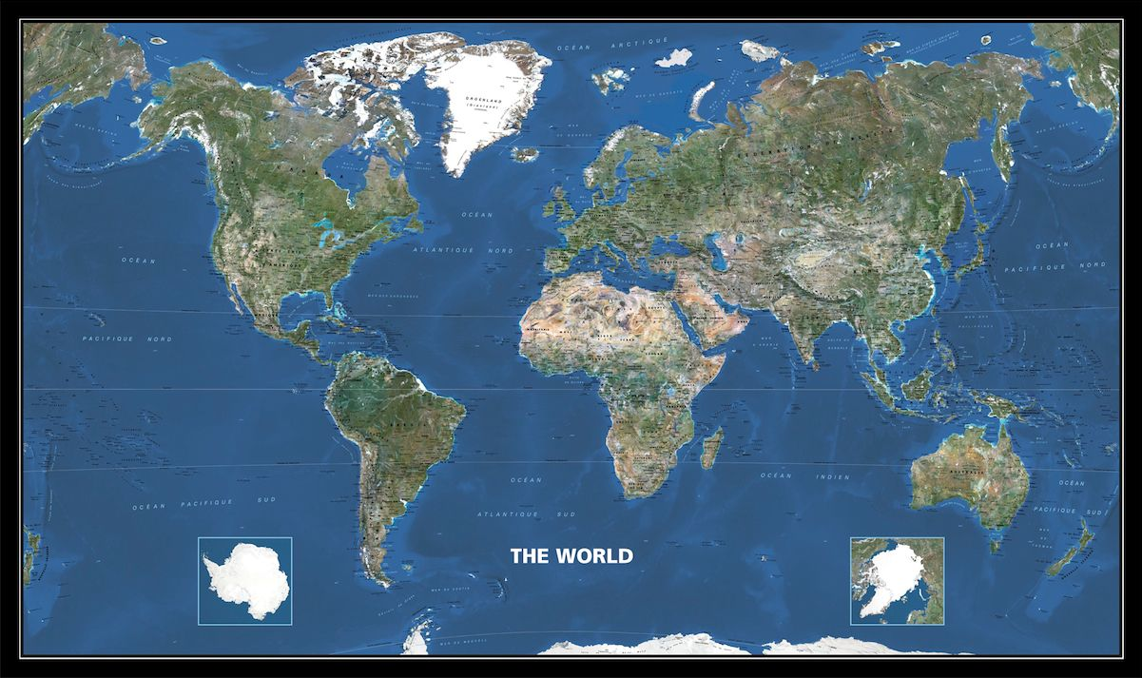

Instructor: Scott Therkalsen
E-mail: scott.therkalsen@gcccd.edu
Class Website: www.grossmont.edu/scotttherkalsen
Class meets: Tues 7:00-9:50 in Room: 36-355
Office Hours: Tues 3:30-7:00; Wed: 11-12:30 Thurs 11:30-12:30 and by appointment
Office: Building 37 room 300-A4
Phone: (619) 644 7358

REQUIRED TEXT and MATERIALS:
Rowntree, Lewis, Price and Wyckoff. 2006. Diversity Amid Globalization: World regions, environment, development. Prentice Hall. ISBN: 9780131330467 -- (3rd or 4th edition)
AND
Kapit, Wynn. Most recent edition. The Geography Coloring Book. Prentice Hall.
OR Veregin. Rand McNally Goodes World Atlas. Rand (21st or 22nd edition)
AND
Internet Access: Students are required to have access to the internet for this course. Utilizing this physical geography online webpage is a vital tool for success:
www.grossmont.edu/scotttherkalsen
**If you need assistance accessing a Grossmont College internet account contact your instructor at the beginning of the course

INTRODUCTION:
Welcome to World Regional Geography 106! This course is an introduction to the physical and cultural elements that combine to create the exciting world around you.
We will investigate how the physical environment is formed and how this influences human activity including culture, religion, politics and more.. Concepts of regional geography will build upon one another as we progress through the semester ending with your ability to explain and assess the major human and physical concepts present in different regions throughout the globe. You are expected to read and write at a proficient college level and actively apply concepts learned in class to real world situations.

CATALOG COURSE DESCRIPTION:
“This course focuses on the overarching principles of cultural geography as applied to regions of the world. Ethnicity, demography, language, religion, settlement patterns, economics and geopolitics provide the framework for comparing and contrasting the world’s six major regions, their cultural and environmental character and current problems and crisis as they impact the global community”

Student Learning Outcomes
- Describe and give examples of how the physical environment interacts with and influences human landscapes, both historically and currently;
- Within the context of world regions, students be able to describe and explain current socio-economic, cultural, and political issues resulting from the important yet interactive and opposing forces of homogenization and diversification (e.g., market vs. socialist economic systems in China; the rise of Islamic extremism; supranationalism and devolution in Europe; uneven economic development in Southeast Asia; etc.).
- Critically analyze current and historical cultural concepts effecting different regions of the world and the inter-relationships between these regions;
- Identify and differentiate physical and cultural features on a map
Explanation of Assignments
Exams (65%):
There will be four exams; 3 covering sectional material and one final covering all material (50% new, 50% old material and spatial timeline). Exams will consist of multiple choice, true and false, and short essay sections. You must bring a “Datalink” form #26760 for each test. There will be no make-up for missed tests.

Map Quizzes (18%)
There will be a total of five map quizzes. They will cover the current sections we are learning about respectively. They will be worth 3.3% each for a total of 20%. There will be no make-up for missed quizzes.

Research Paper (10%):
There will be one research paper reinforcing concepts learned in class. For the paper you will choose 2 of the world regions we will cover to compare and contrast integrating each of the 5 major themes discussed throughout the course into your paper. The paper will be assessed for the information presented as well as grammar, syntax, and organization (more information will be provided at a later date).

Regional events assignment (7%):
As we cover each region in class each week you will be required to relate a current event from the region we are covering to one or more of the five major themes discussed throughout the course. Your research will include events covered in newspapers, magazines and on the Internet. Each region will be accompanied by an assignment that must be researched and completed in full be the due date for full credit; NO LATE ASSIGNMENTS WILL BE ACCEPTED (more information will be provided at a later date).

ASSESSMENT:
Assessment was created to provide students with different abilities the opportunity to demonstrate their knowledge in a variety of manners.

Assignment Points Possible % of Total Grade
Map Quizzes (5) 15 points each 3.6% each
Map Quiz Totals 75 points 18%
Exam One 65 points 15.5%
Exam Two 65 points 15.5%
Exam Three 65 points 15.5%
Exam Four *(Check Date) 75 points 15.5%
Exam Totals 270 points 65%
Geography Paper 40 points 10%
Regional event assignments 30 points 7%

Total Points Possible 415 points 100%

MQ1_____ + MQ2_____ + MQ3_____ + MQ4_____ + MQ5_____ + + E1______ + E2______ +

E3______ + E4______ + GP ______+REA_______=_____/415

*You should be actively tracking you grades through the website:eclassinfo.com (your ID# is your GC student number and your password is your 6 digit birthday)
Grading Scale
A 90-100% 373.5-415 points
B 80-89% 332-373 points
C 70-79% 290.5-372 points
D 58-69% 240-290 points
Failing 57% and below 236.5 and below
Credit/No Credit 70-100% for credit 290 and up

*Notice there is no extra credit so plan accordingly!
GENERAL POLICIES:
Attendance and Behavior
Inappropriate behavior of any kind in the classroom will not be tolerated. You are expected to come to every class prepared and ready to work. Students may be dropped from class for failure to attend the first week or for excessive absences. If necessary it is your responsibility to officially withdraw from the course before the final drop deadline.
The most important strategy for succeeding in this course is to come to class eager to learn, participate and critically think. There will be no makeup quizzes or exams. No late assignments will be accepted. As adults you are expected to respect your classmates by coming to class on time, acting appropriately and refraining from using any electronic devices during class; students with cell phones visible during class will be asked to leave (voice recorders and electronic translators may be used with permission but no electronic translators may be used during tests).

Preparation for Class
Students should always bring a pencil/pen, colored pencils, 3 ring binders and their textbook to every class meeting. Readings listed in the course schedule should be completed prior to the class meeting and prior notes should be reviewed and questions generated prior to each class meeting. The class website should be visited weekly and the current lecture topic should be reviewed. These actions will insure that you will be well prepared to actively participate in discussions and class activities.

Students with Disabilities
“Students with disabilities who may need accommodations in this class are encouraged to notify the instructor and contact Disabled Student Programs and Services (DSPS) early in the semester so that reasonable accommodations may be implemented as soon as possible. Students may contact DSPS in person in Room 110 or by telephone at (619)644-7112 or (619)644-7119 (TTY for deaf).”

Behavior and Academic Integrity
“Cheating and plagiarism (using as one’s own ideas, writings or materials of someone else without acknowledgement or permission) will result in any one of a variety of sanctions. Such penalties may range from an adjusted grade on the particular exam, paper, project or assignment (all of which may lead to a failing grade in the course) to, under certain conditions, suspension or expulsion from a class, program or the college. For further clarification and information on these issues, please consult with your instructor or contact the office of the Associate Dean of Student Affairs.”

Supervised Tutoring Referral
Students are referred to enroll in the following supervised tutoring courses if the service indicated will assist them in achieving or reinforcing the learning objectives of this course:
English 198W, Supervised Tutoring for assistance in the English Writing Center (Room 70-119); and/or IDS 198T, Supervised Tutoring to receive one-on-one tutoring in academic subjects in the Tutoring Center (Room 70-229, 644-7387).
CLASS SCHEDULE
*This is only a tentative schedule; you will be notified of any changes as they occur throughout the semester
DATES | CONCEPTS | ROWNTREE READINGS | ASSIGNMENTS DUE
08/19/2014 | Introductions  The Physical Environment
08/26/2014 | Climate and Geology | Chapter Two
09/02/2014 | Population and Culture  Geopolitics and Development | Chapter One | Definition Handout Due
09/09/2014 | The Role of Geography  North America | Reading Handout  and start Chapter 3 | Map Quiz 1
09/16/2014 | North America  The Caribbean | Finish Chapter 3  (Skim chapter 5)
09/23/2014 | EXAM ONE  Latin America | Chapter Four | EXAM ONE
9/30/2014 | Europe | Chapter Eight | Map Quiz 2
10/07/2014 | Southwest Asia and North Africa | Chapter Seven
10/14/2014 | Sub-Saharan Africa | Chapter Six | Map Quiz 3
10/21/2014 | EXAM TWO  And Russia |  | EXAM TWO
10/28/2014 | Russia  Central Asia | Chapter Nine  And skim Ten | Map Quiz 4
11/04/2014 | South Asia | Chapter Twelve
11/11/2014 | NO SCHOOL |  | NO SCHOOL
11/18/2014 | East Asia | Chapter Eleven | Research Paper Due
11/25/2014 | EXAM THREE  And Southeast Asia |  | EXAM THREE
12/02/2014 | Southeast Asia  Oceania | Chapter Thirteen and skim 14 | Map Quiz 5
12/09/2014 | FINAL EXAM 8:15-10:15 |  | FINAL EXAM

