Participation in this day-long event requires a $50 minimum donation at time of registration, payable securely online via credit card. Just visit the Creative Writing Program’s official website, www.grossmont.edu/english/cw, to get started.
Your Name Phone
Street Address City State Zip
E-Mail (will not be sold or shared)
- Participation in the Write-a-thon starts with a minimum of $50 in donations, made securely online to The Foundation for Grossmont & Cuyamaca Colleges: Creative Writing Fund. Use the 2019 Creative Write-a-Thon registration form on the office Creative Write-a-Thon page of the Grossmont College Creative Write-a-Thon website: www.grossmont.edu/english/cw.
- DONATIONS can be made by you on behalf of your sponsors, or they can be made by your sponsors directly. The Grossmont College Foundation is a 501 (c) non-profit organization. Donations are tax deductible.
- A qualifying $50 minimum donation should be submitted online no later than 12 noon on Friday, November 15, 2019. Use the form below to help keep track of your WRITE-A-THON sponsors and donation amounts. Participants are solely responsible for securing the pledged donations of their sponsors. Additional donations beyond the $50 minimum can be submitted online via credit card at any time, and in person by cash or cheque on the morning of the Write-a-Thon.
- Participants will receive 1 raffle ticket per $10 raised. Grand prize laptop computer to be awarded at the end of the Write-a-Thon. For all prize opportunities, you MUST be present to win.
Donor’s Name (first & last) | Donor’s Contact Info  (e-mail / phone #)) | Amount  Donated | ^{Check, cash or}  ^{online credit card donation?} | CWP USE ONLY
Example:  Ima Donor | imadonor@cox.net / 619-555-2011 | 10.00 | Cash
1.
2.
3.
4.
5.
6.
7.
8.
9.
10.
11.
12.
13.
14.
15.
16.
17.
18.
19.
20.

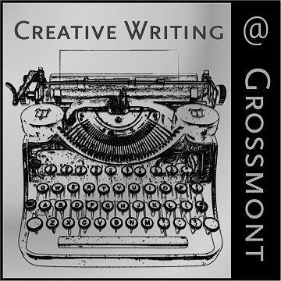
WRITE-A-THON ADMIN USE ONLY

Name _______________________________

Cash $____________ Checks $ _____________

Credit/ATM$__________________________

Total $ __________________________________

Initials___________

Total $ _________________
(combined pledges must total a minimum of $50.00)
Waiver: “I understand and acknowledge that the organizers, instructors, the Grossmont-Cuyamaca Community College District and Grossmont College make no warranties implied or otherwise regarding the 2019 Creative Write-a-Thon, and that refunds for myself, or donors, are not available.”

Signature

Grossmont - Cuyamaca Community College District • 8800 Grossmont College Drive El Cajon, CA 92020-1799 • (619) 644-7000 • www.gcccd.edu •Governing Board Members: Elena Adams, Linda Cartwright, Bill Garrett, Debbie Justeson, Brad Monroe Student Members: Amy Bianchi, Sonia Mendoza - Reyes • Chancellor: Cindy L. Miles, Ph.D., Grossmont College President: Nabil Abu-Ghazaleh, Ed.D.

