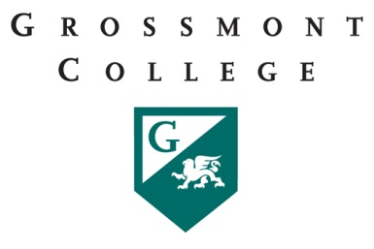

Grossmont College
Part-Time Faculty Committee
Monday, September 26, 2016
11:00am – 12:20pm in 53-553

AGENDA ITEMS
 | DISCUSSION ITEMS | FOLLOW UP ACTION | COMMUNICATION
1 | Follow up on P.T. committee work compensation
2 | Office Hours
3
4
5

